Jenkins Master Slave Configuration

Github Link: https://github.com/NiteeshManne?tab=repositories

1)Login to the AWS console.

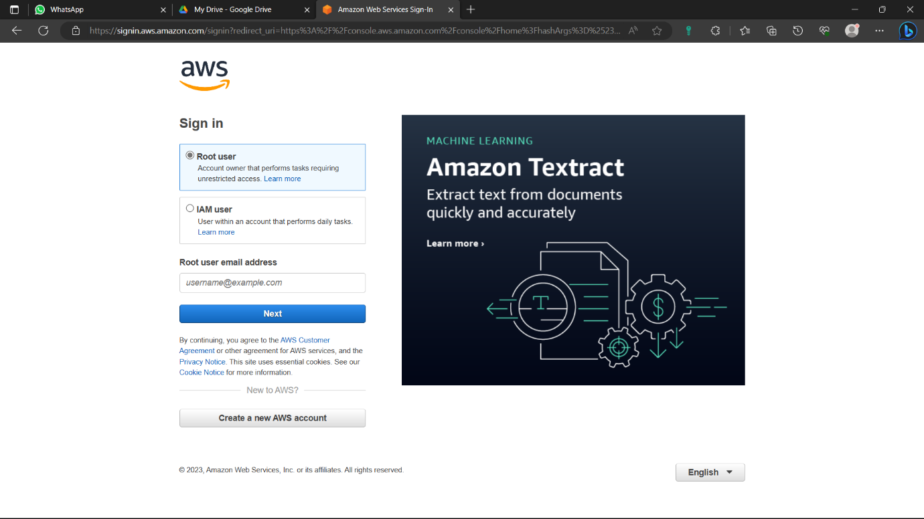

2)Type “EC2” and select the “EC2” option from below.

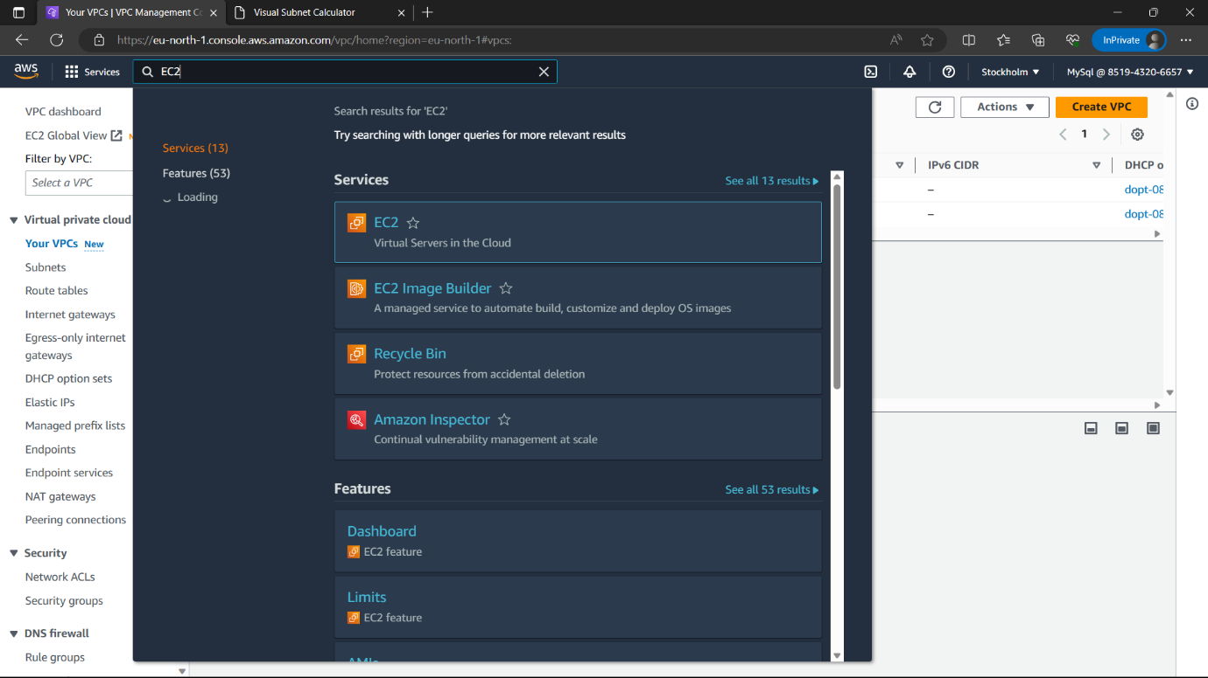

3)Click on “Launch instance” option which is in colour.

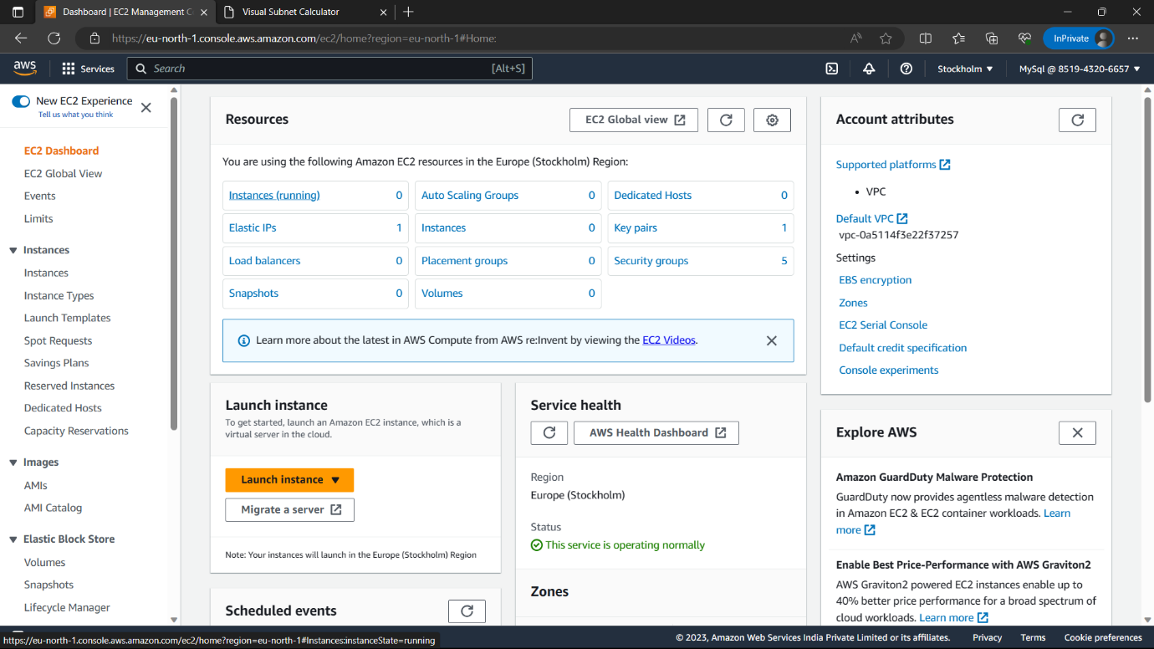

4)Name-“jenkins master”.

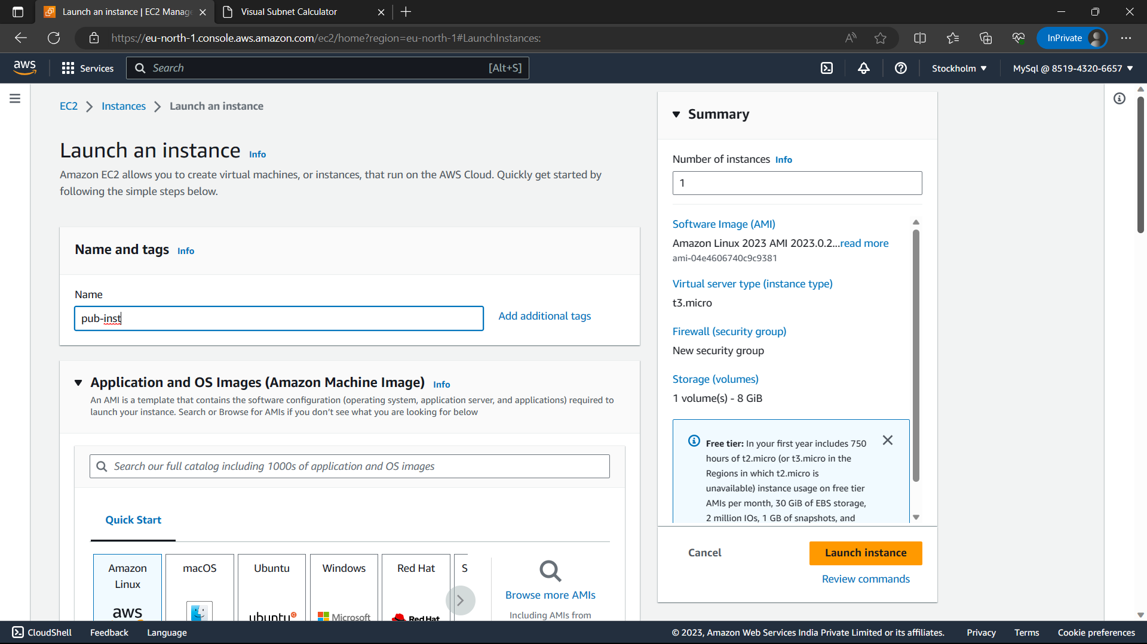

5)AMI-“Amazon linux”, Version-latest, Instance type-t3.micro(free-tier eligible).

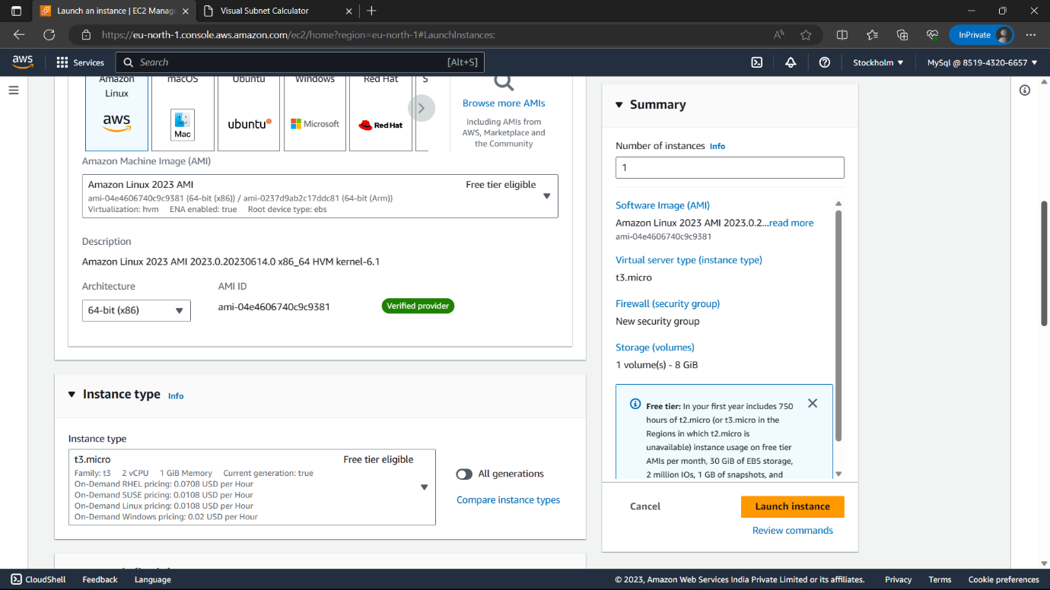

6)Select the key pair you have else click on “create new key pair”🡪name🡪Click on “create key pair” a copy of the key pair is downloaded in you local machine.

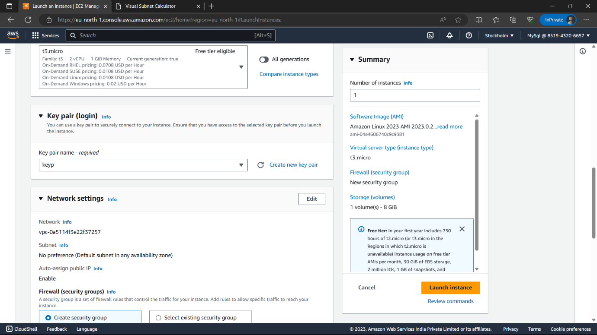

7)Enable “Allow HTTPS traffic” option, Review everything and click on “Launch Instance” option.

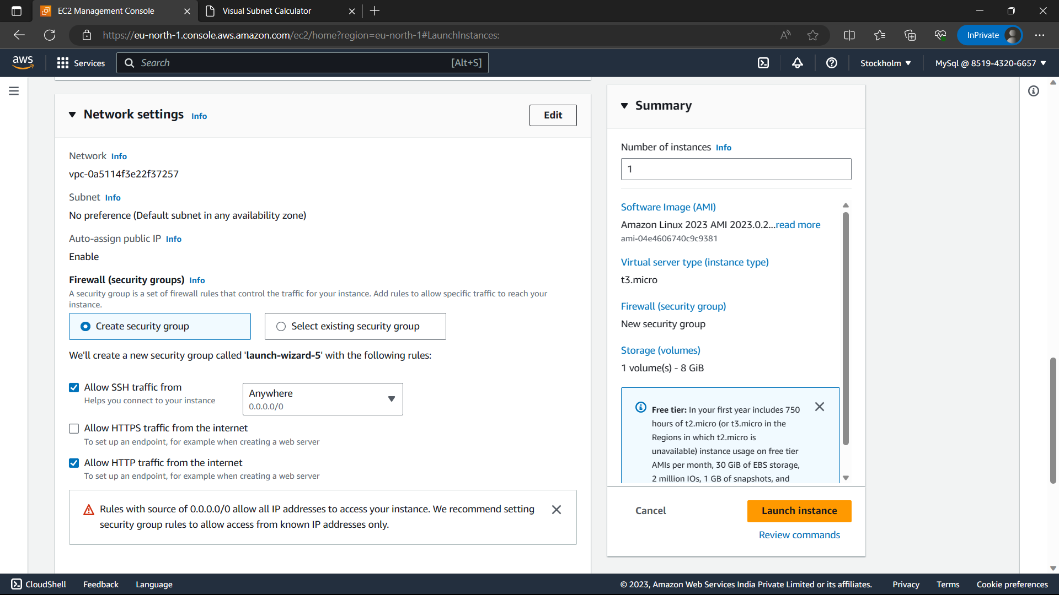

8)Now create another instance.

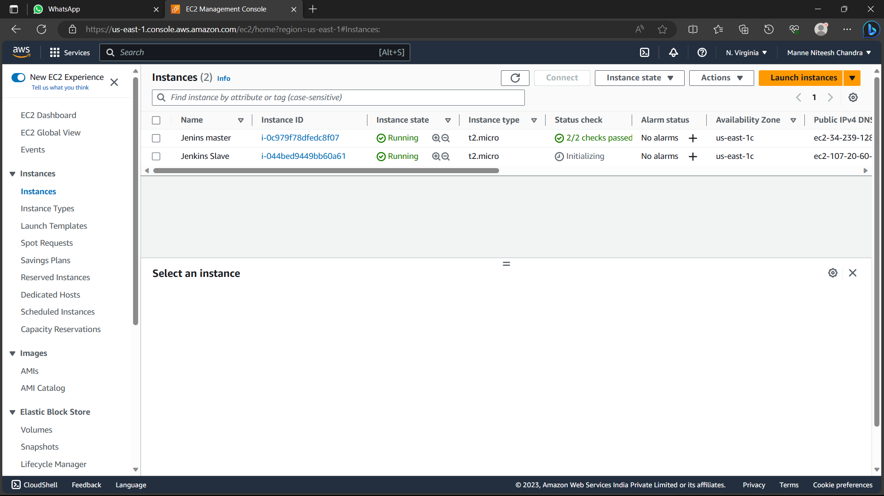

9)Now Access the Jenkins master instance by selecting the Jenkins master instance and click on connect and browse to ssh client and copy the command below the example. Paste it in command prompt now you can access the instance.Access the instance in you’re local machine.

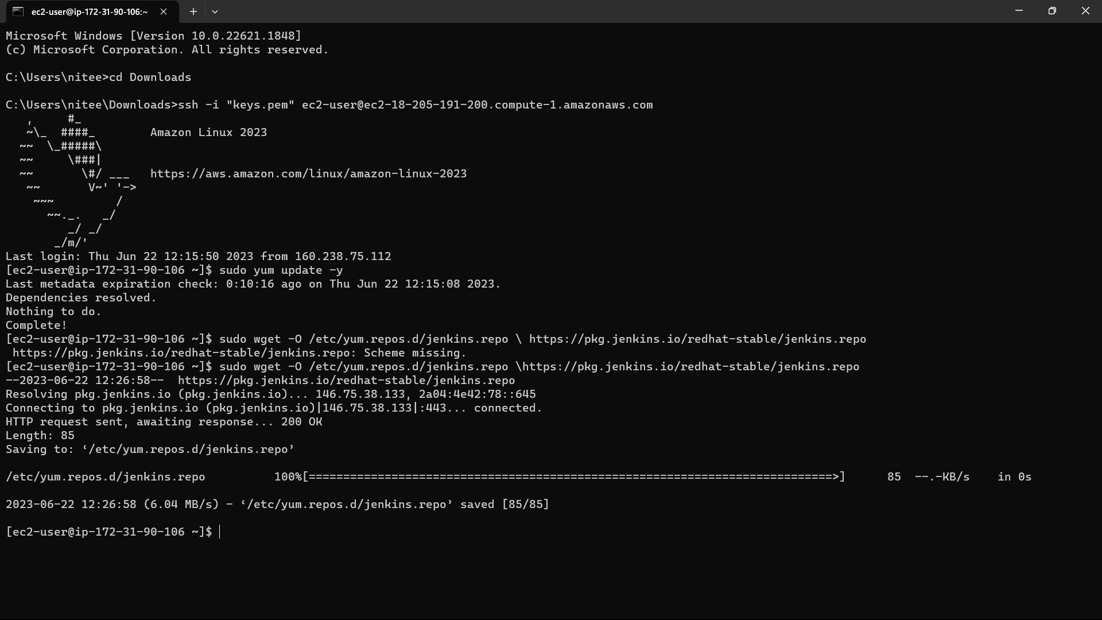

10) <https://www.jenkins.io/doc/tutorials/tutorial-for-installing-jenkins-on-AWS/>. Paste this link in the browse and copy the installation commands and paste in you’re instance.

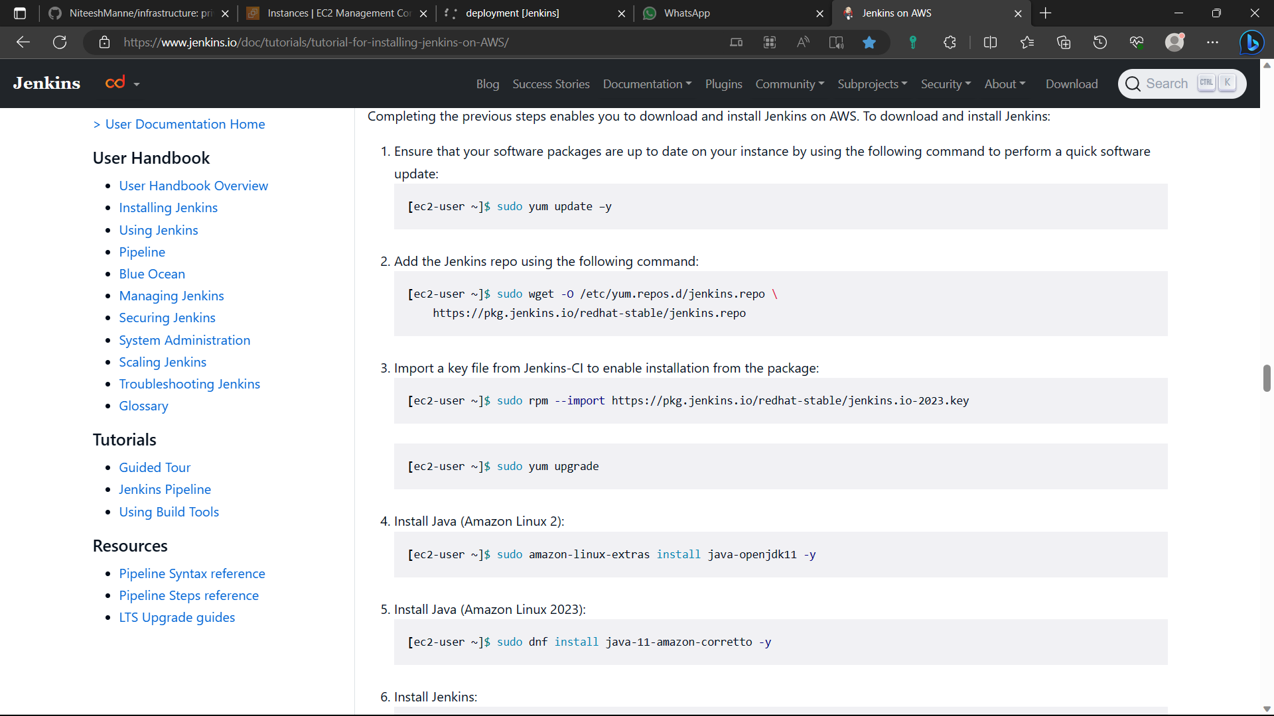

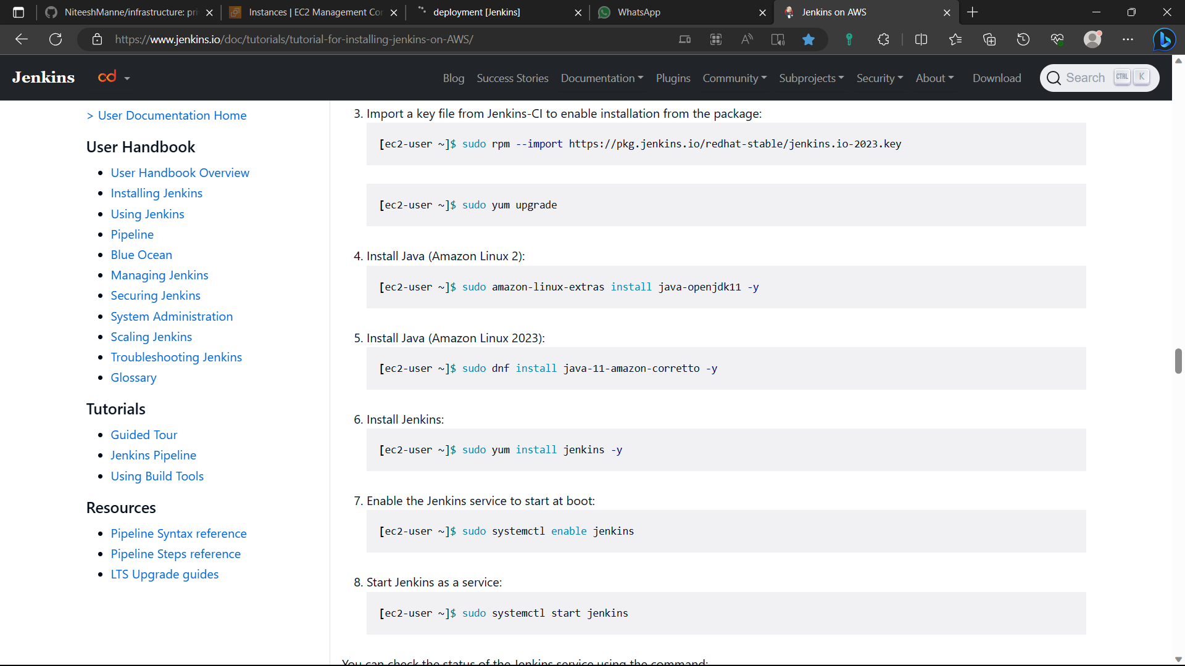

11)The Jenkins is installed in the instance.

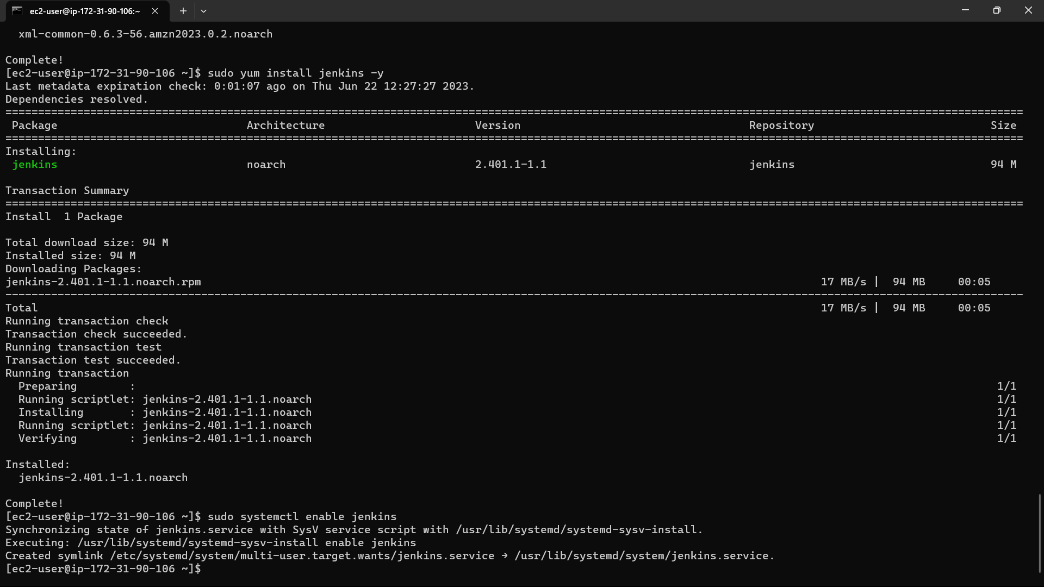

12)Now install git in the instance using the command “sudo yum install -y git”.

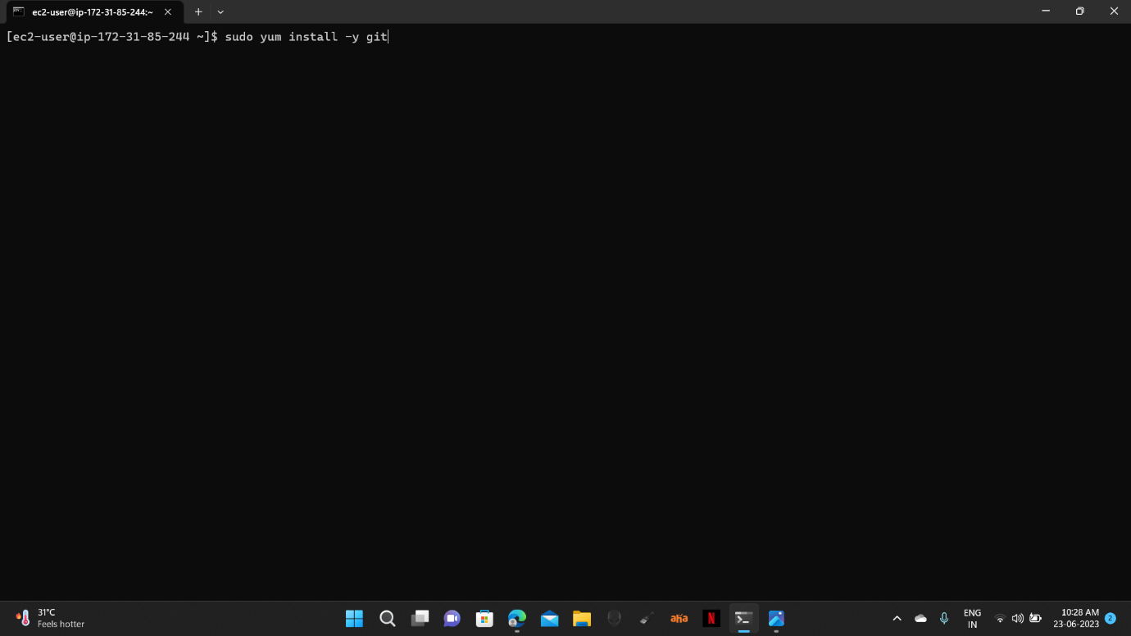

13)Now type the command “sudo visudo” for linux file.

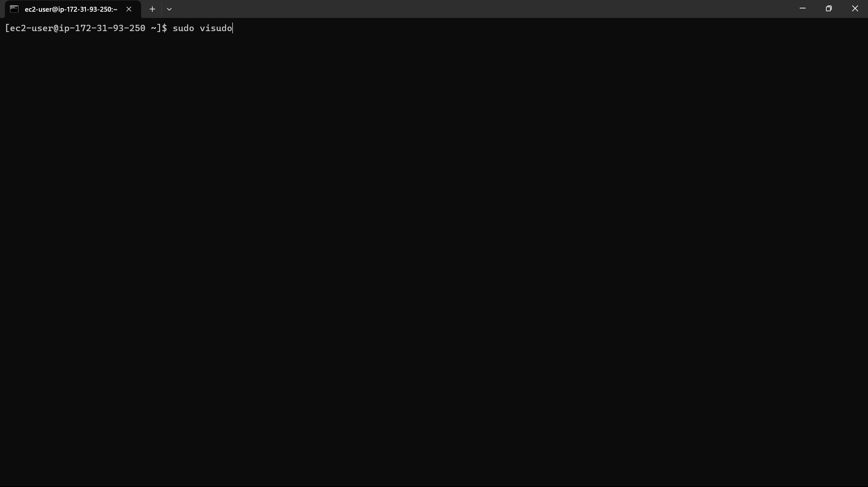

14)The file is opened. Go down and add an extra line below the root user i.e.,

“jenkins ALL=(ALL) NOPASSWD: ALL”. The ctrl+s, ctrl+x.

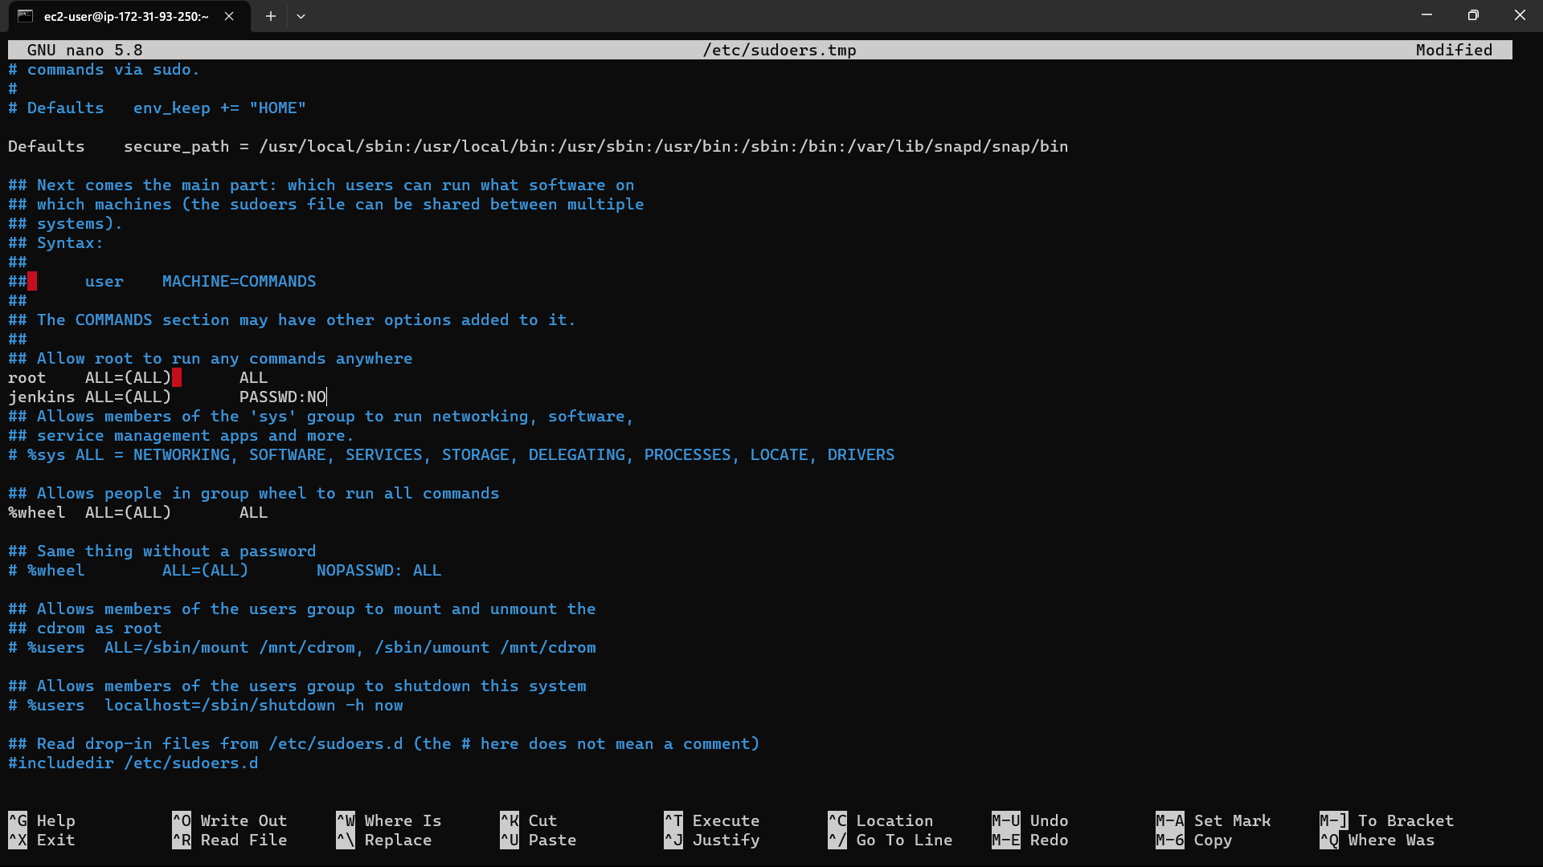

15)Go to the instances in console and select the instance you created.

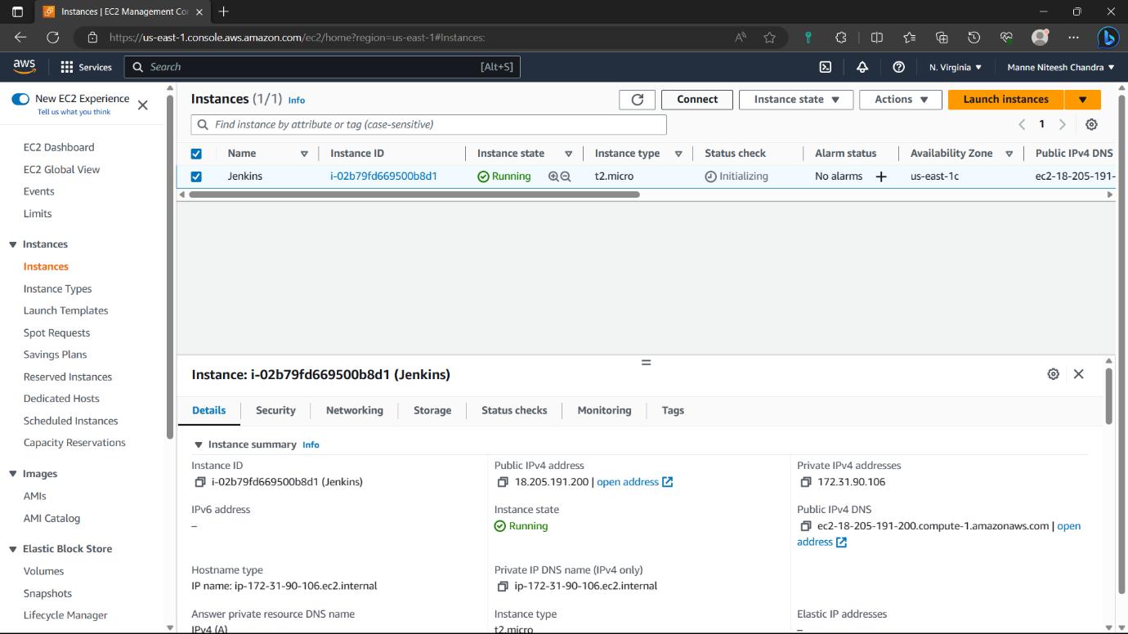

16)Navigate to security of the instance and click on the security group.

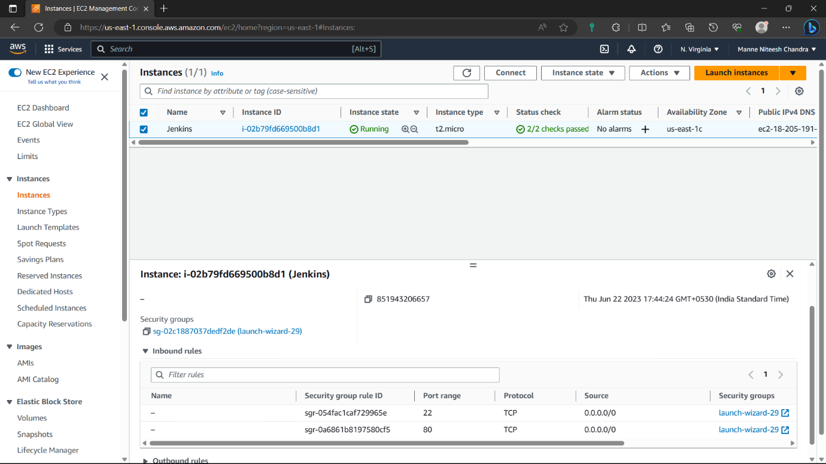

17)Click on “edit inbound rules” option.

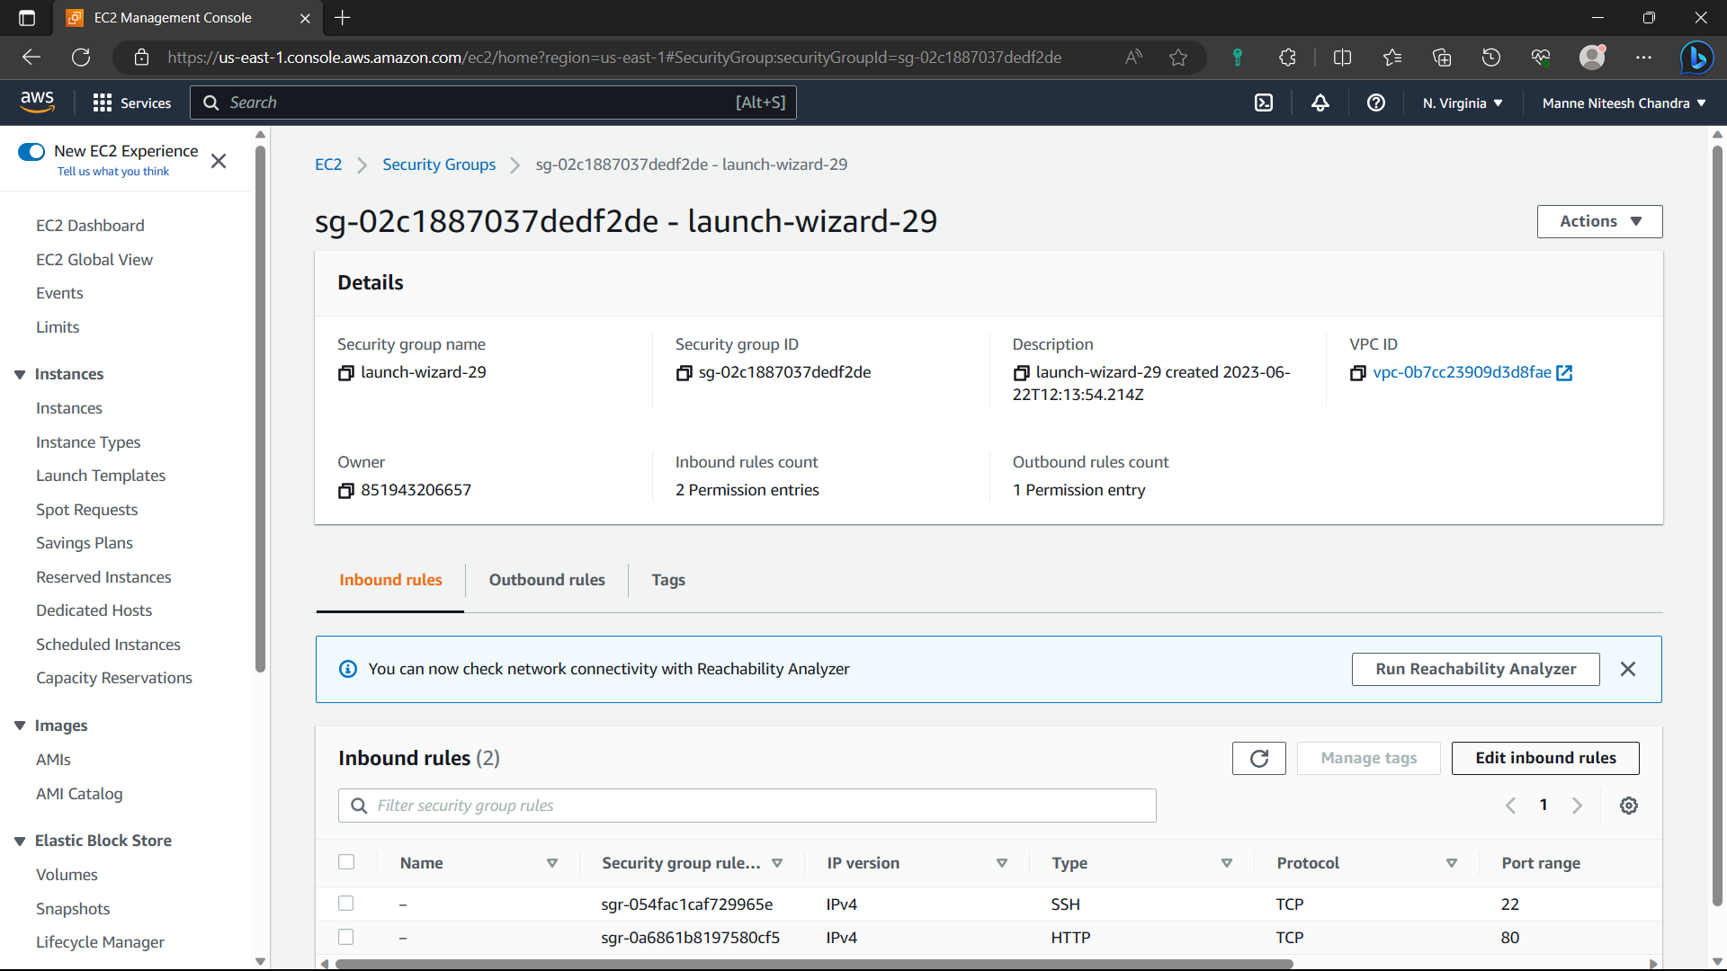

18)Click on “Add rule”.

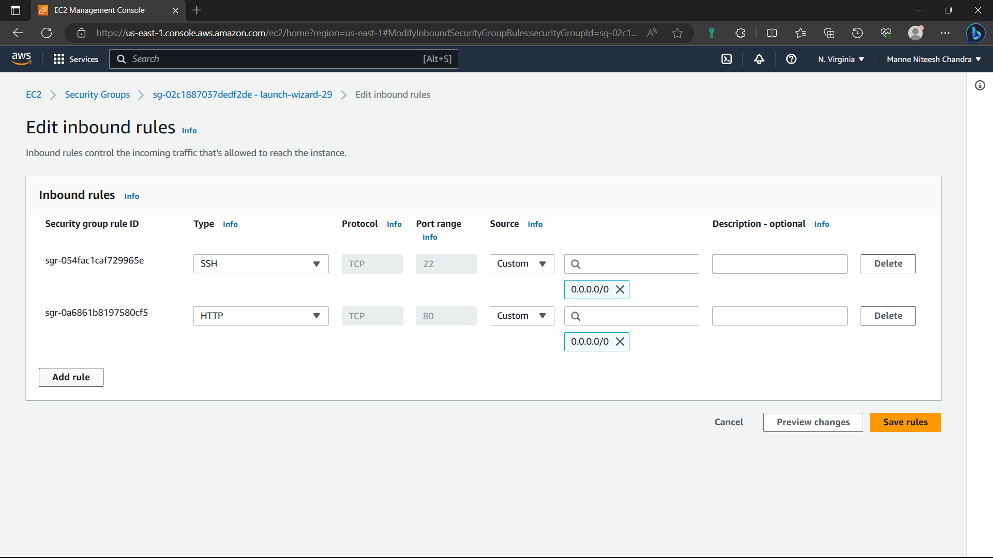

19)Type-Custom, port-8080, cidr-0.0.0.0/0 and click on “save rules” option.

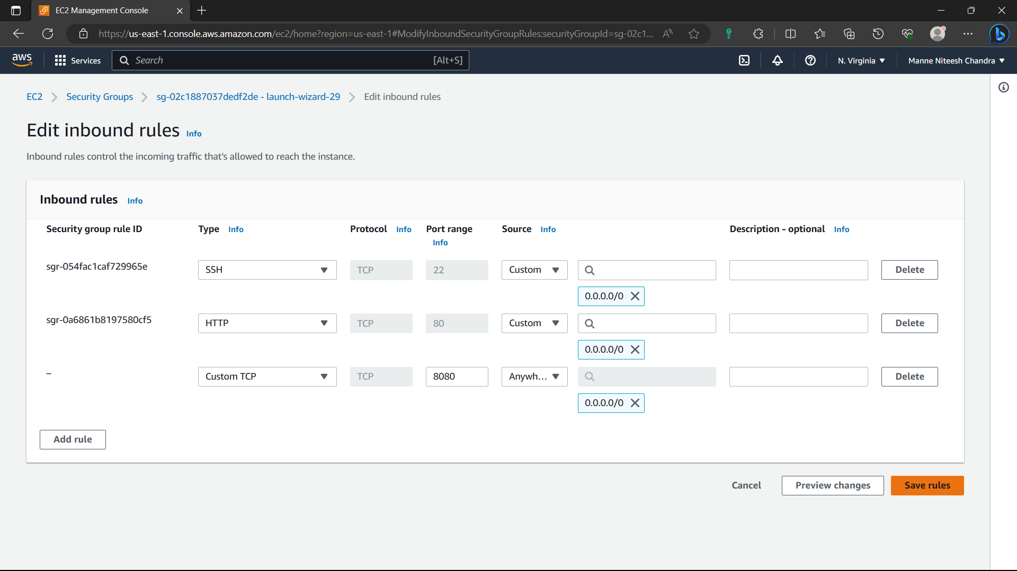

20)Now the rule is saved.

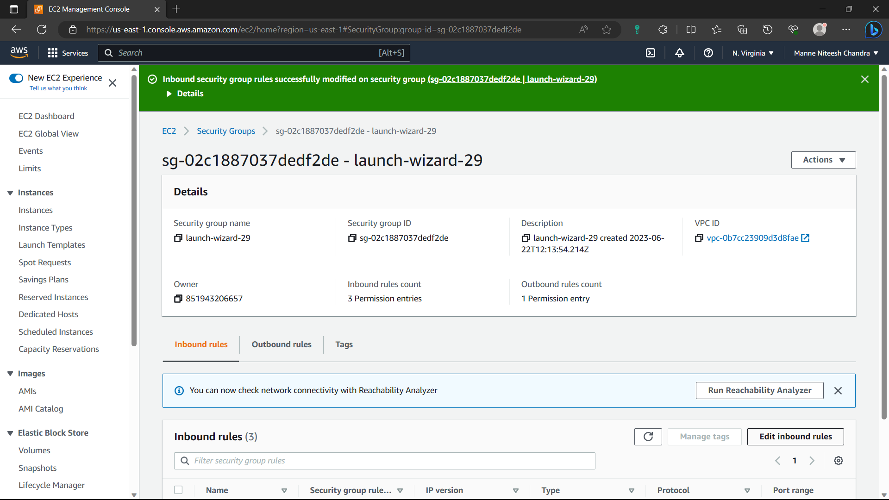

21)Go to “Instances” and select the instance you created and copy the ipv4address.

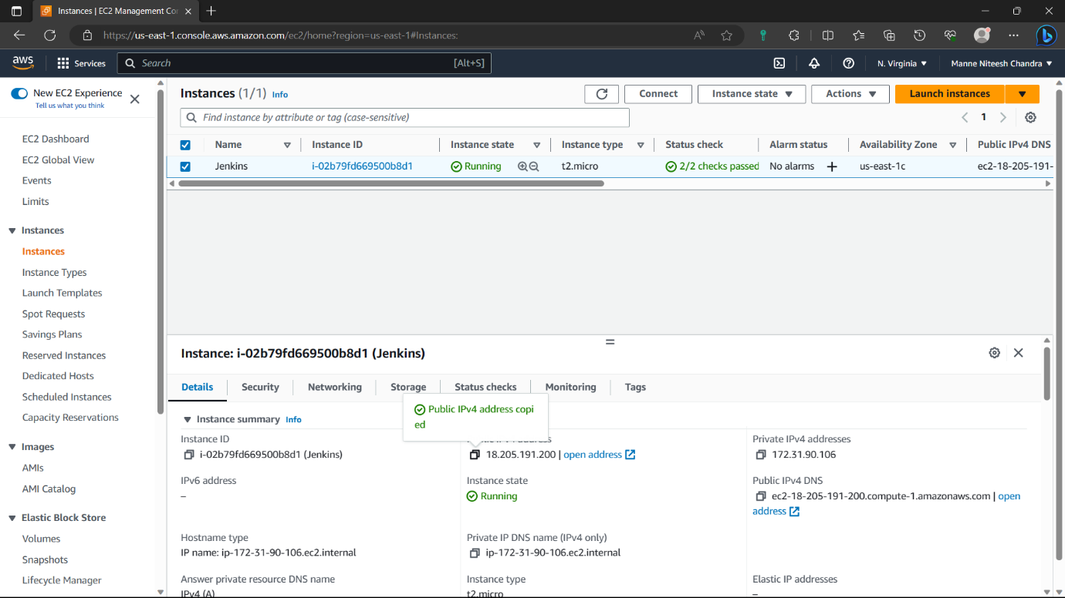

22)Before pasting it in browser add ”:8080” to the ipv4address to open Jenkins in the browser. Jenkins is opened in browser. Copy the pathi.e., in red colour.

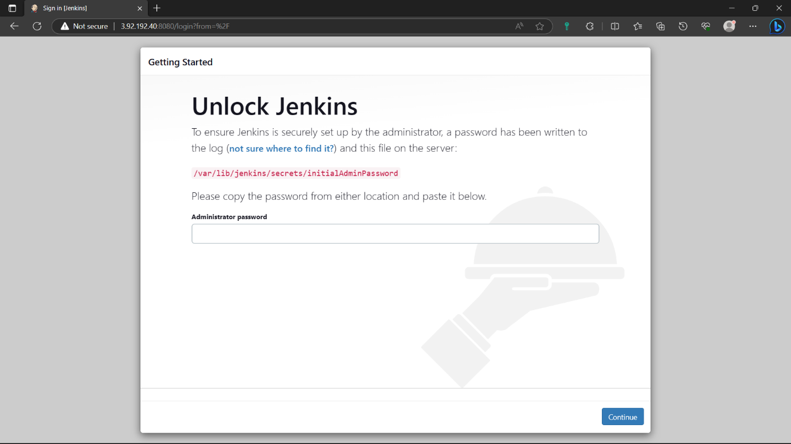

23)go to instance and type the command “sudo cat path”: for password to create Jenkins account.

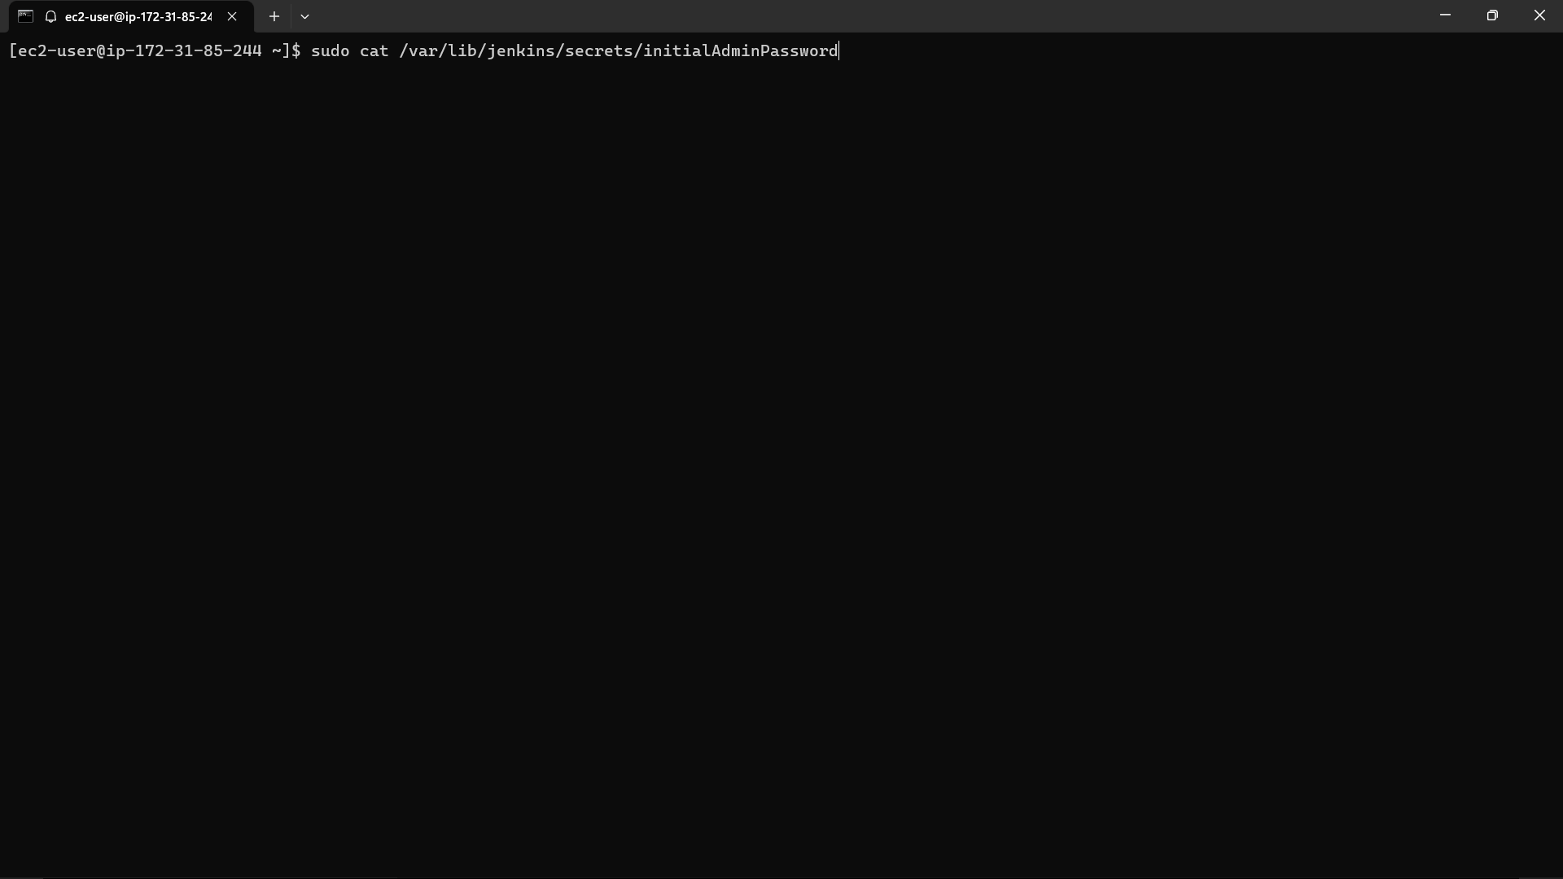

24)Copy the output and paste it in the Jenkins and click on continue.

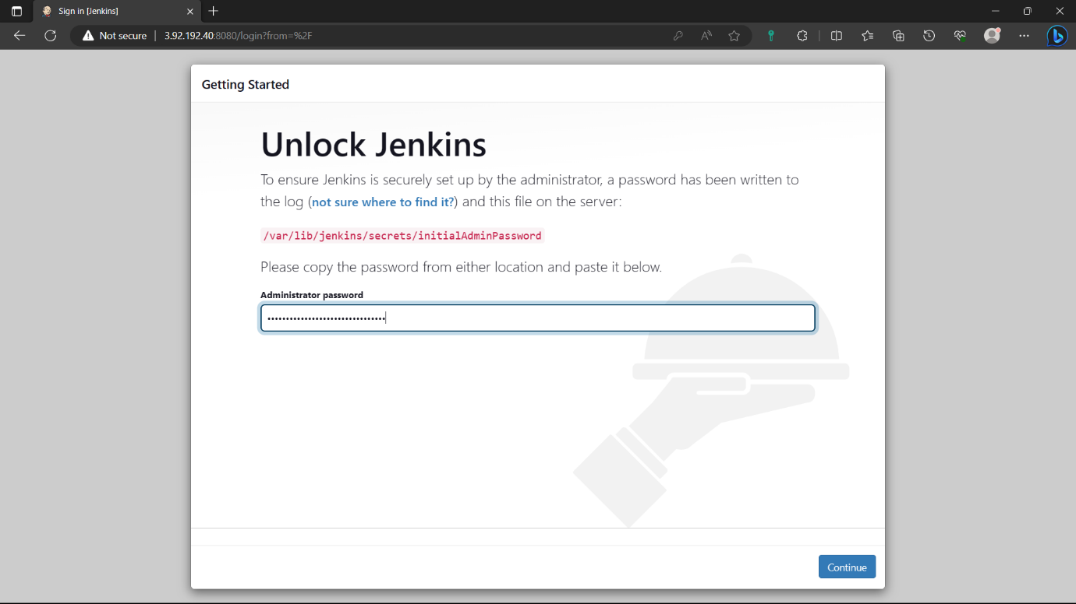

25)Select the “Install suggested plugins” option. And wait for some to install required plugins.

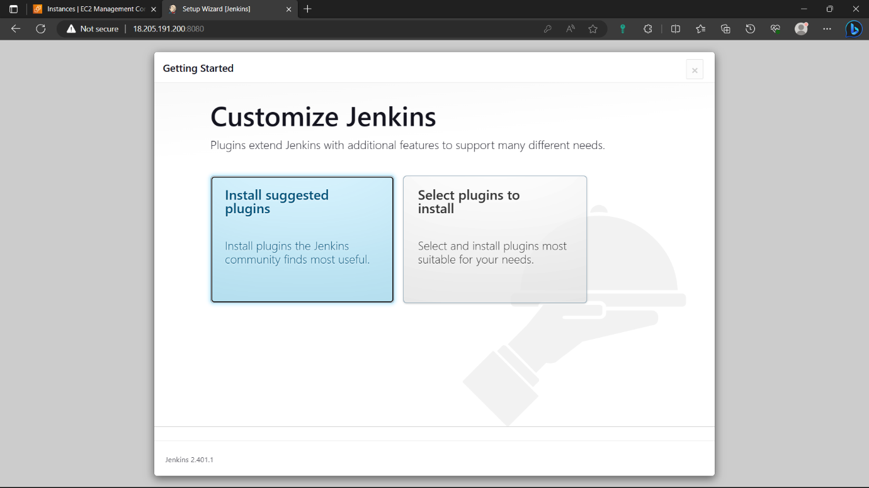

26)Give credentials to create an account click on “save and continue” and click on “continue” again.

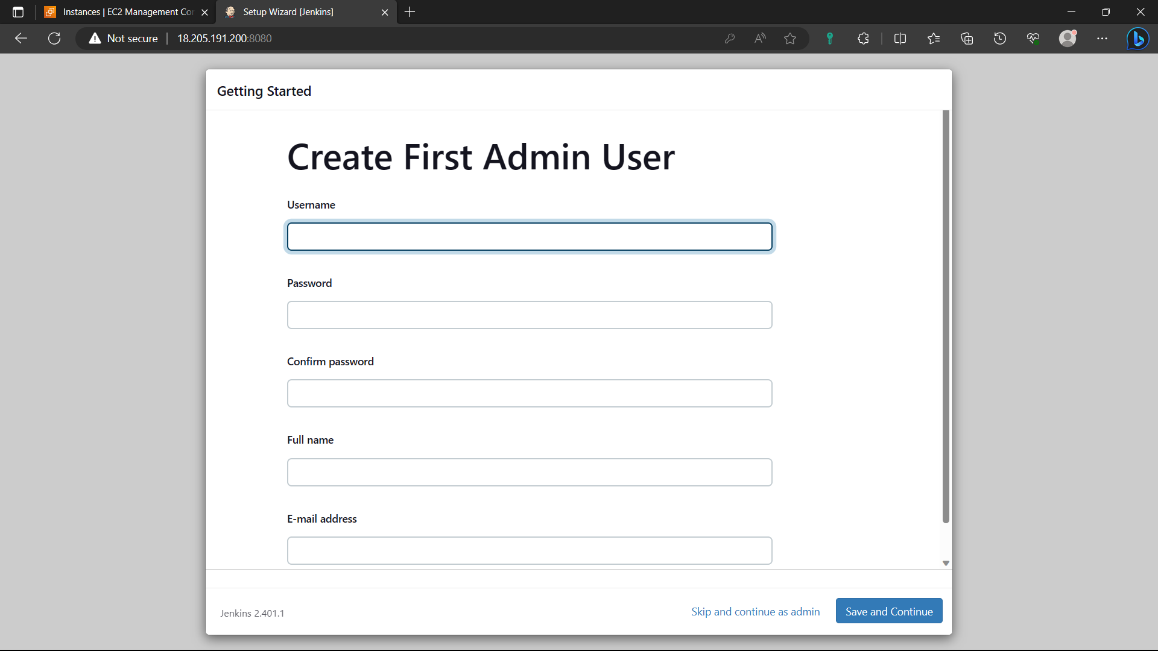

27)click on “start using Jenkins”.

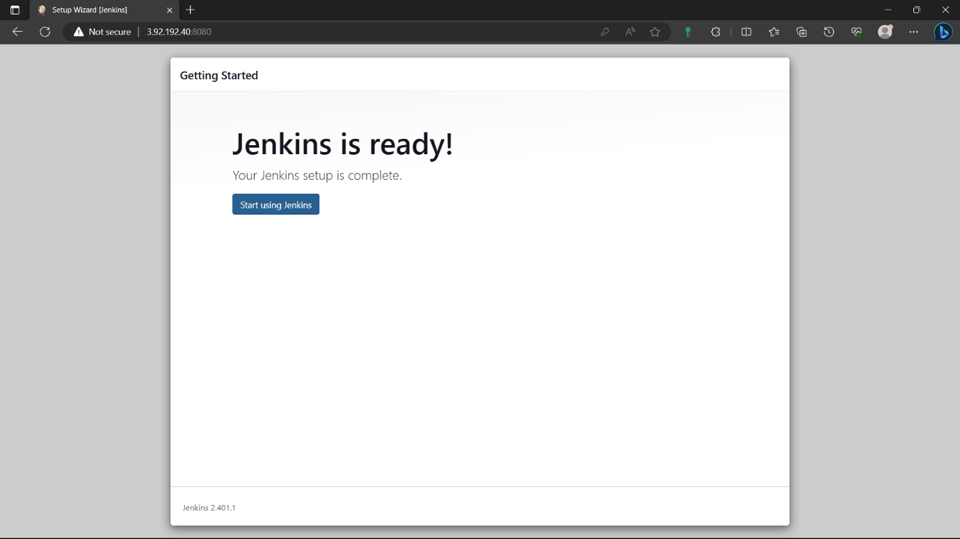

28)Access the Jenkins slave instance in your local machine. Create a slave user and assign password and login as a slave and create a ssh private key in that slave by using the commands shown in below image.

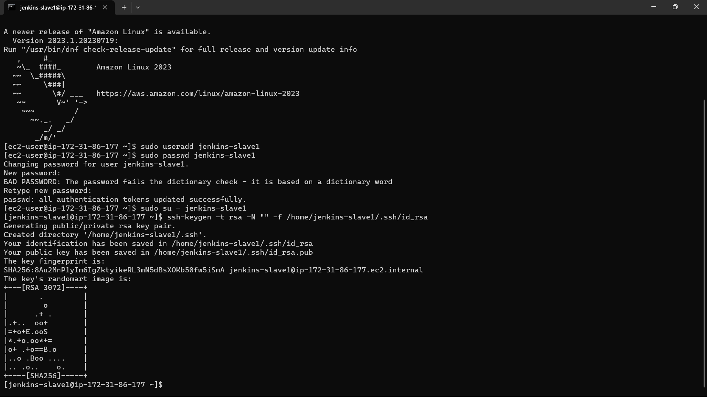

29)Now navigate to the .ssh and change the permission of “authorized_keys” with the below command “sudo chmod 700 authorized_keys”.

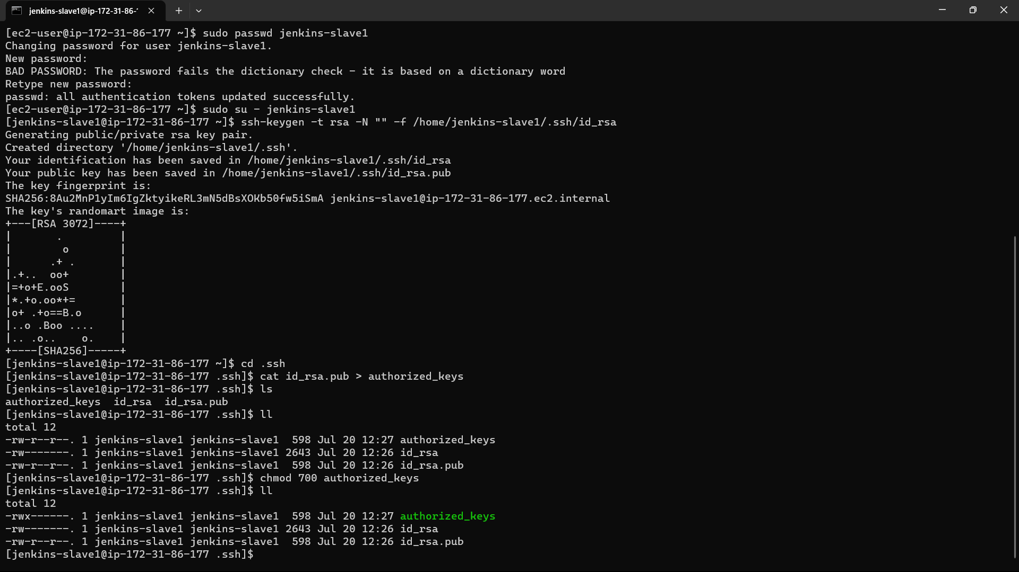

30)Open another cmd terminal and access Jenkins master instance in that terminal and create a directory in .ssh.

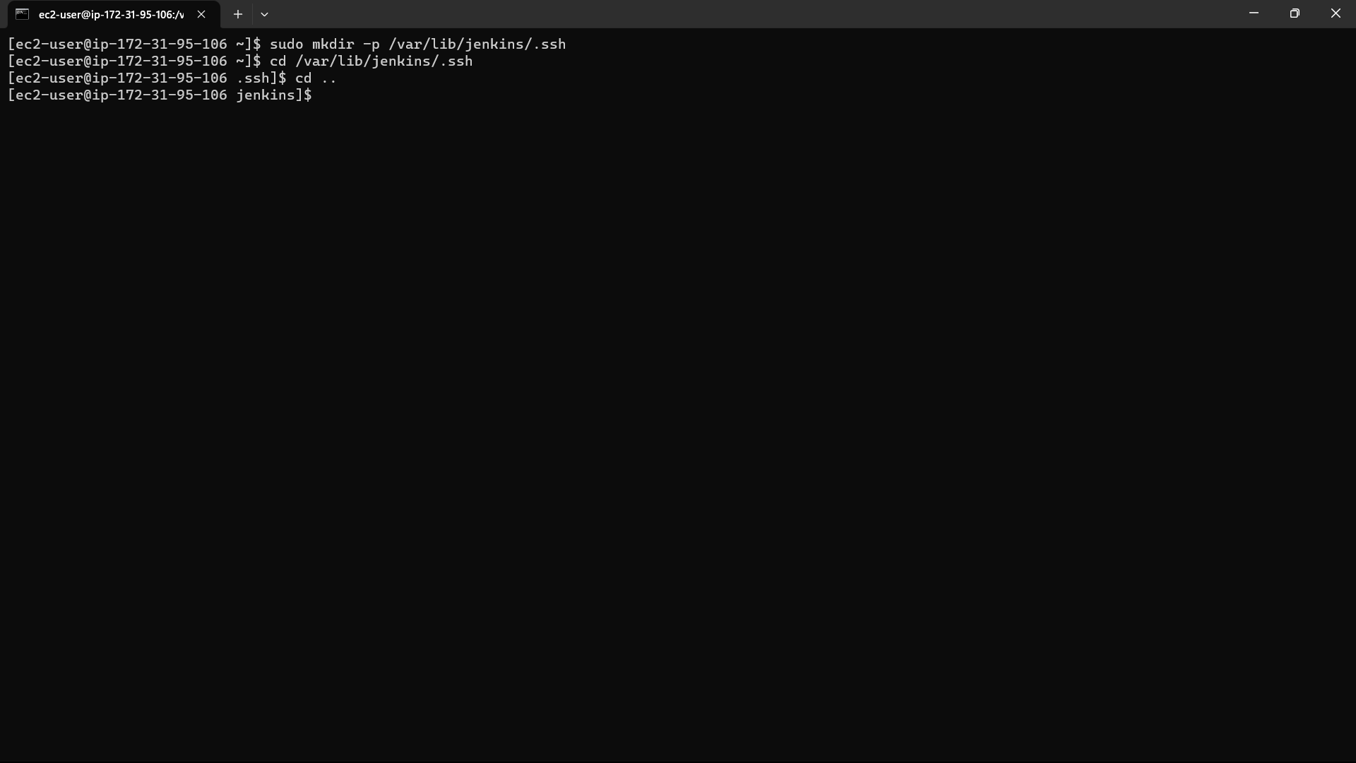

31)change the permission of the .ssh file “sudo chmod 777 .ssh”

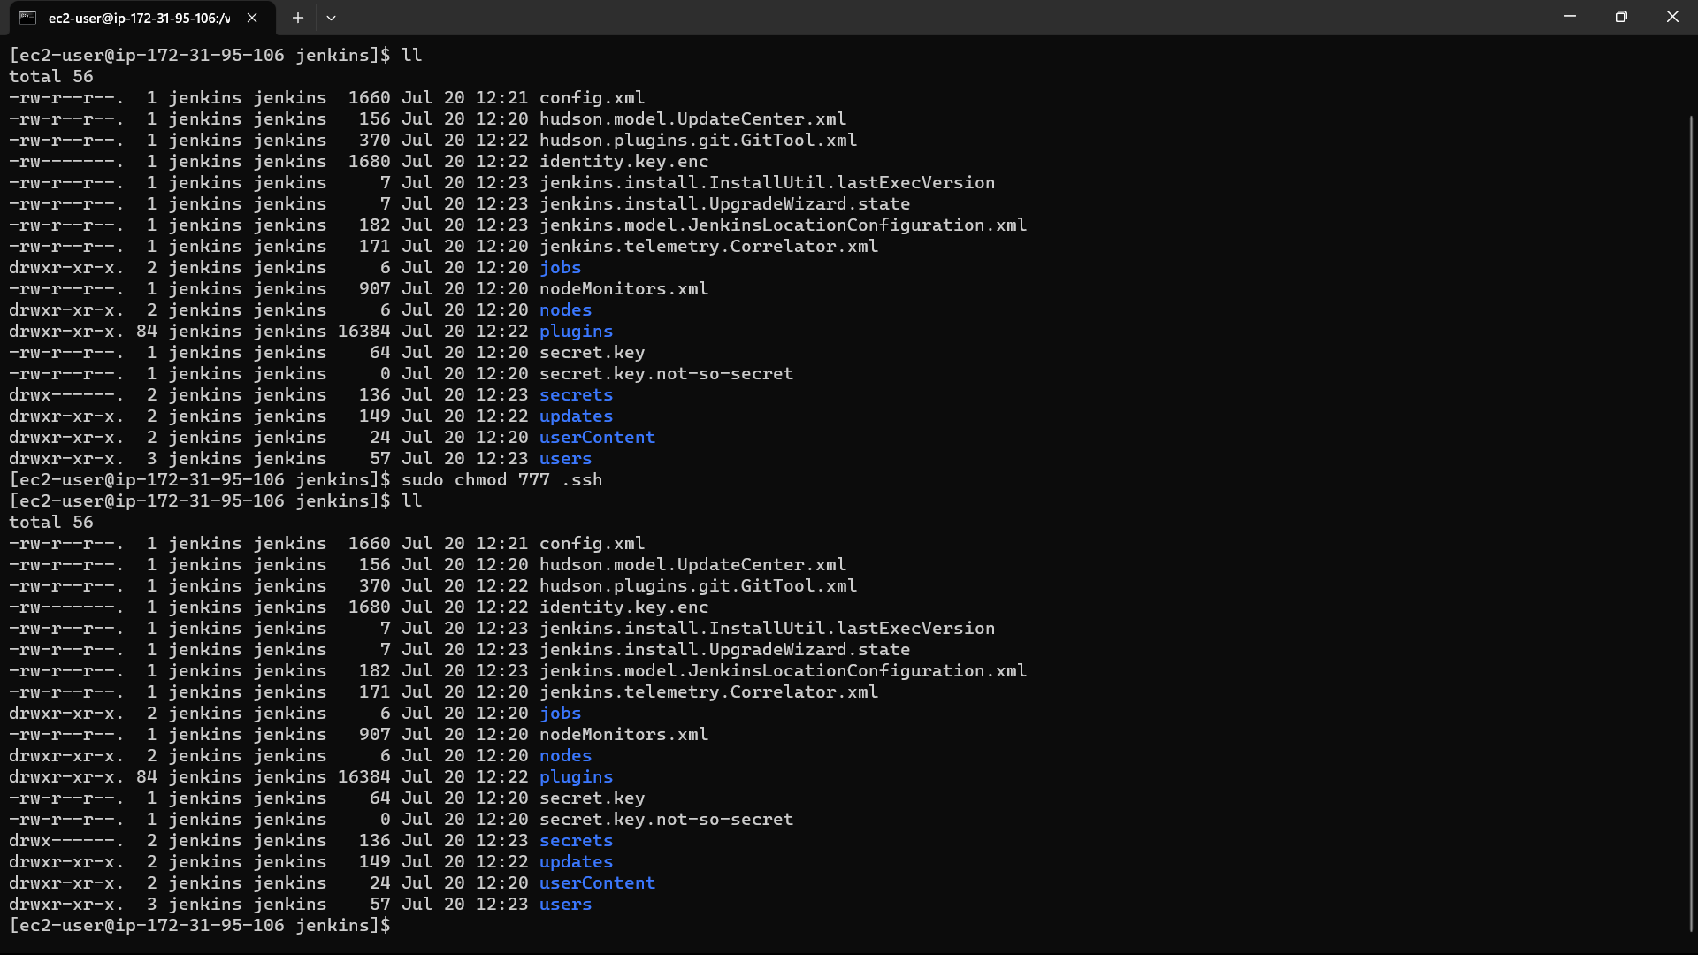

32)Now scan the private ip address of the slave instance to known hosts of master

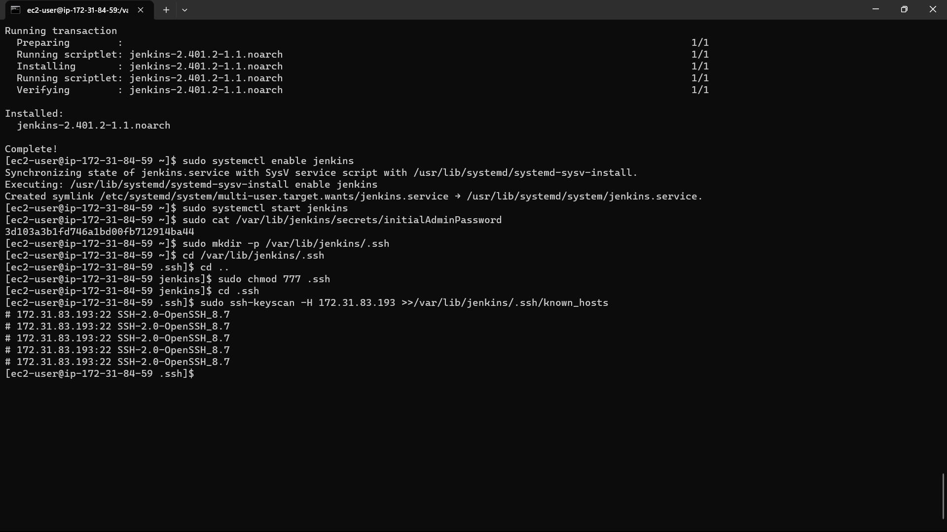

33)Click on “manage Jenkins”

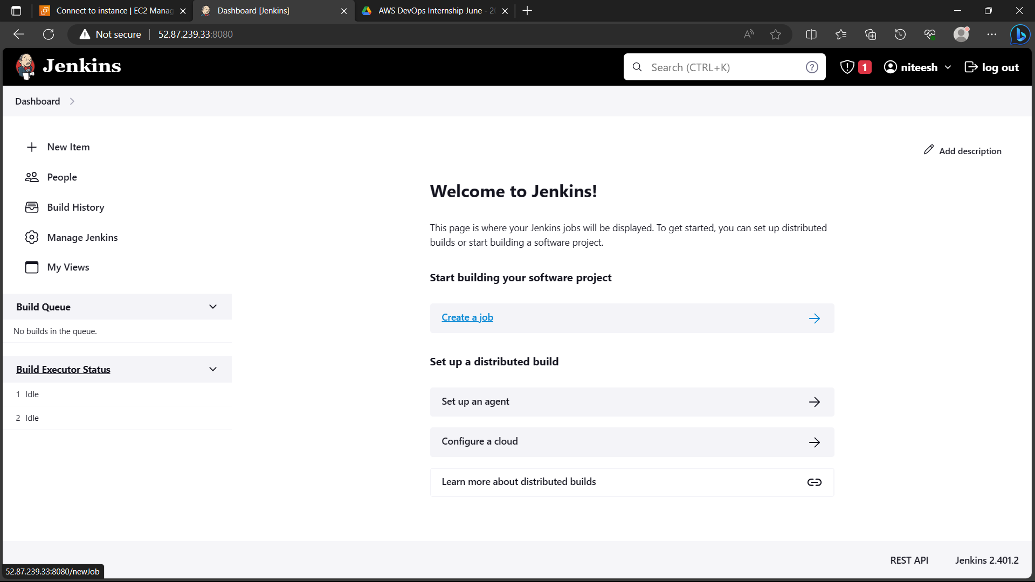

34)Click on “nodes and clouds”.

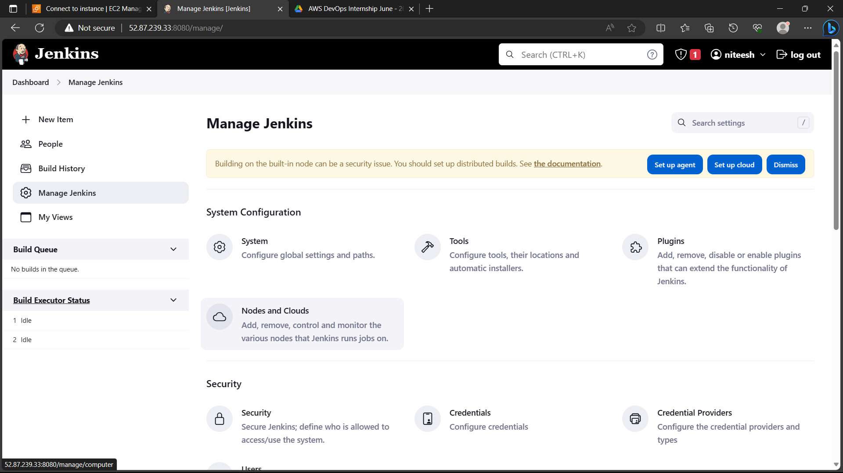

35)Click on “New node”.

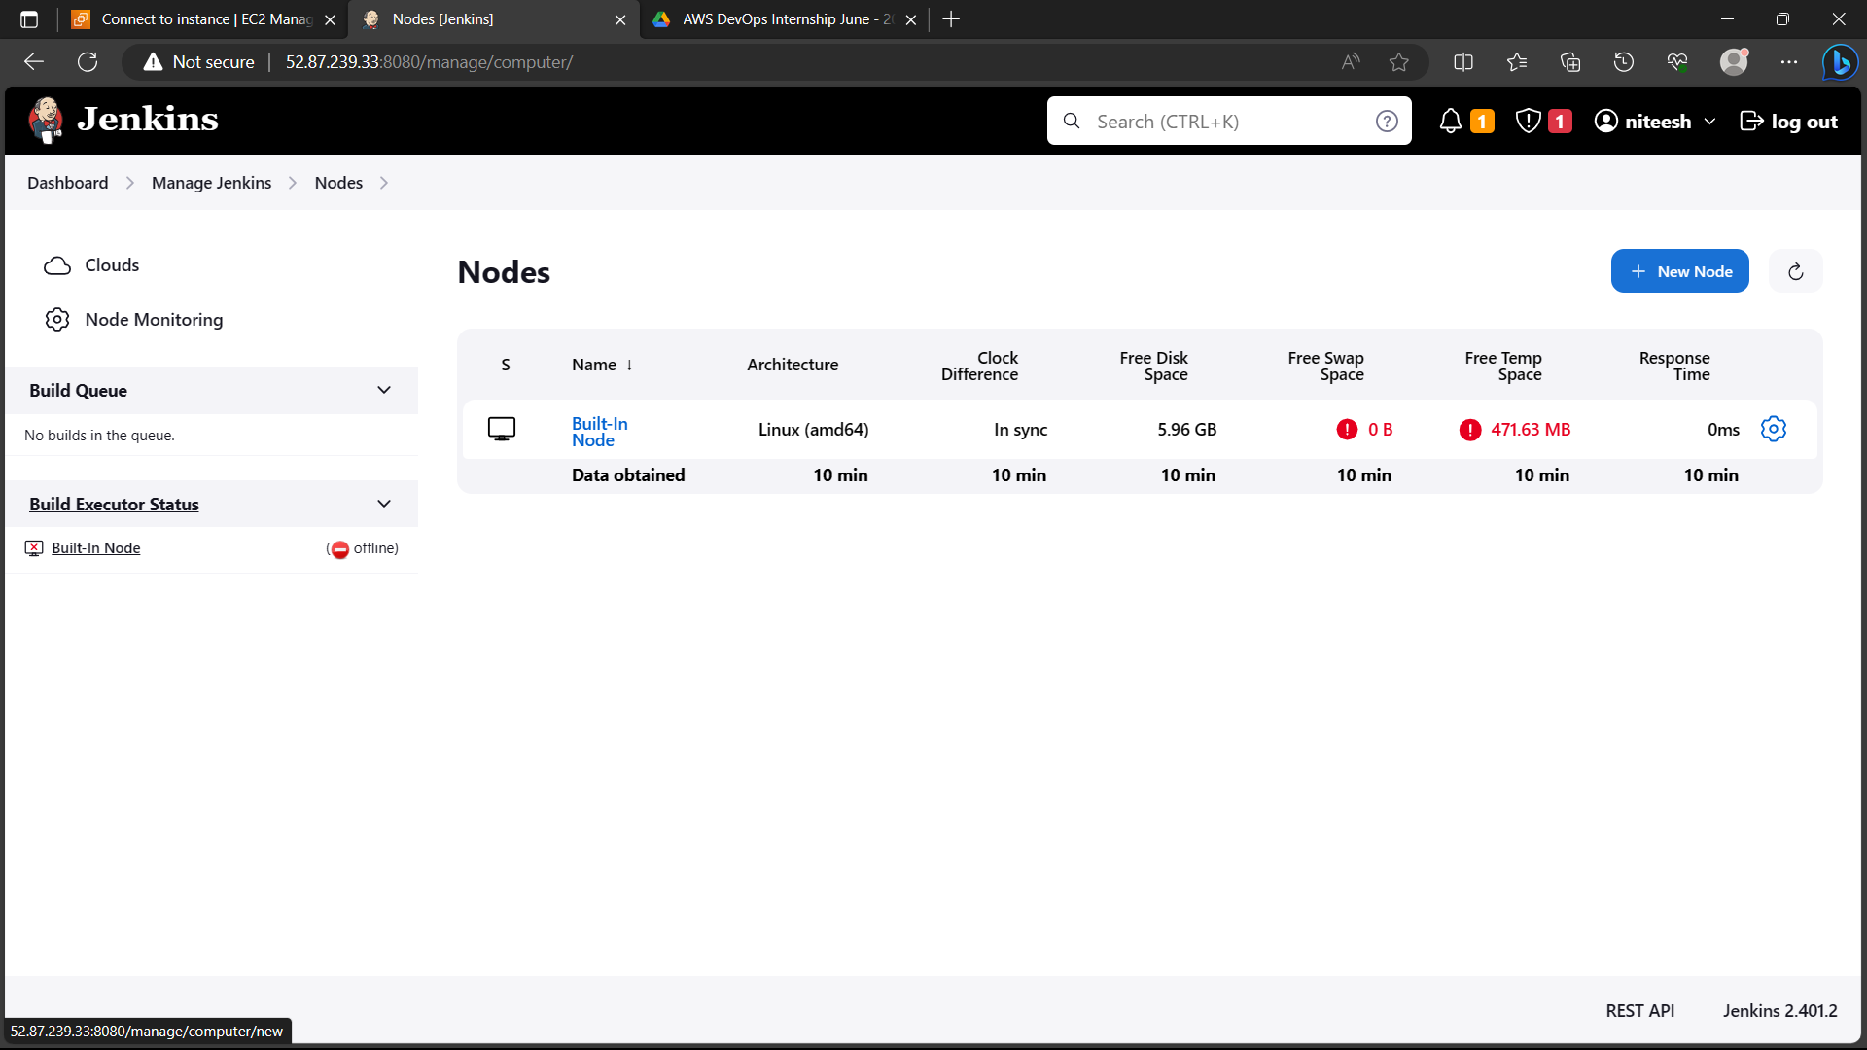

36)give a name and select permanent agent and click on ok

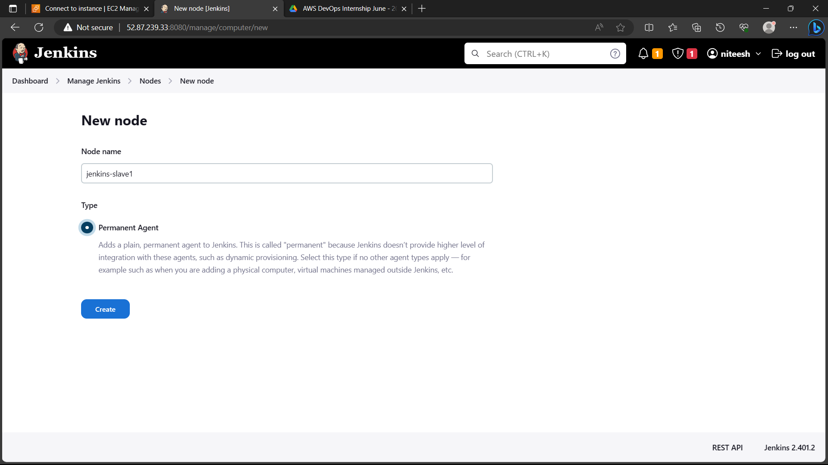

37)give path as “/home/Jenkins-slave1” in remote root directory

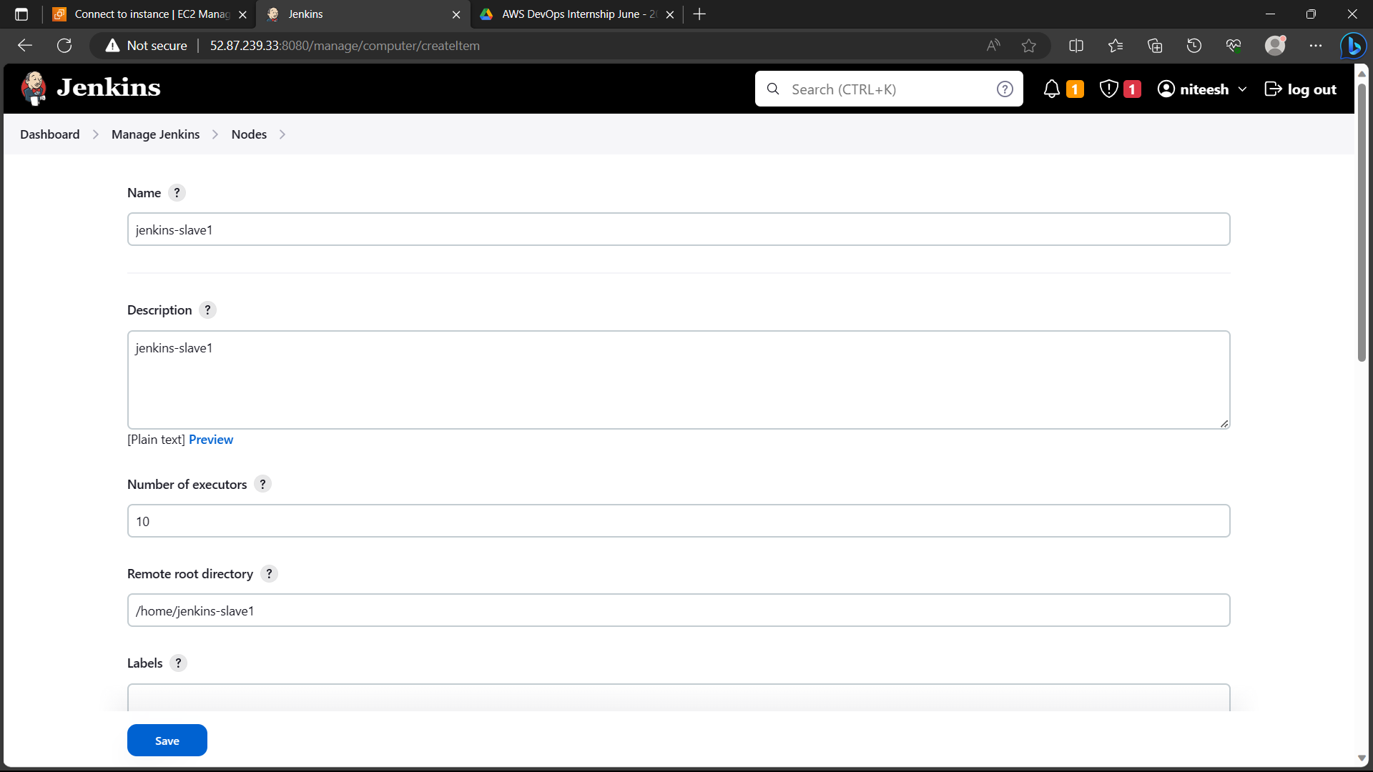

38)Select “launch agent via SSH”

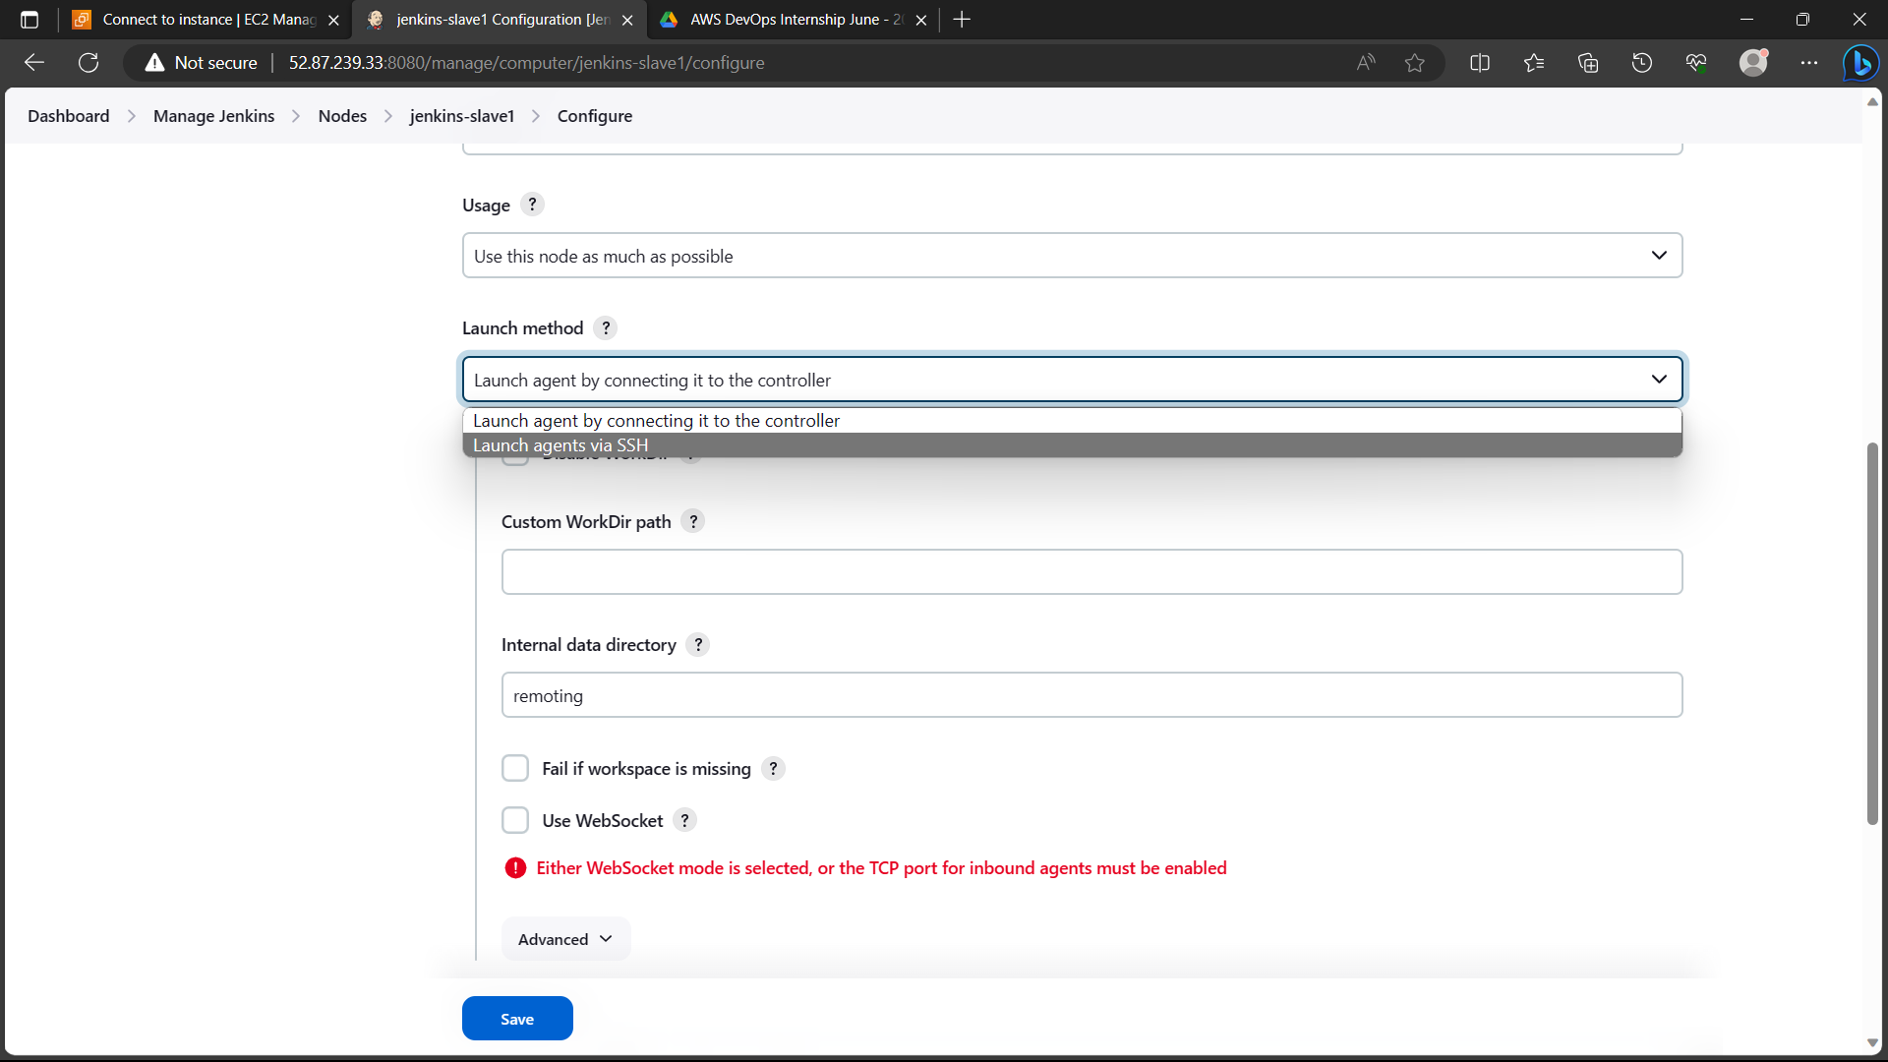

39)Add credentials

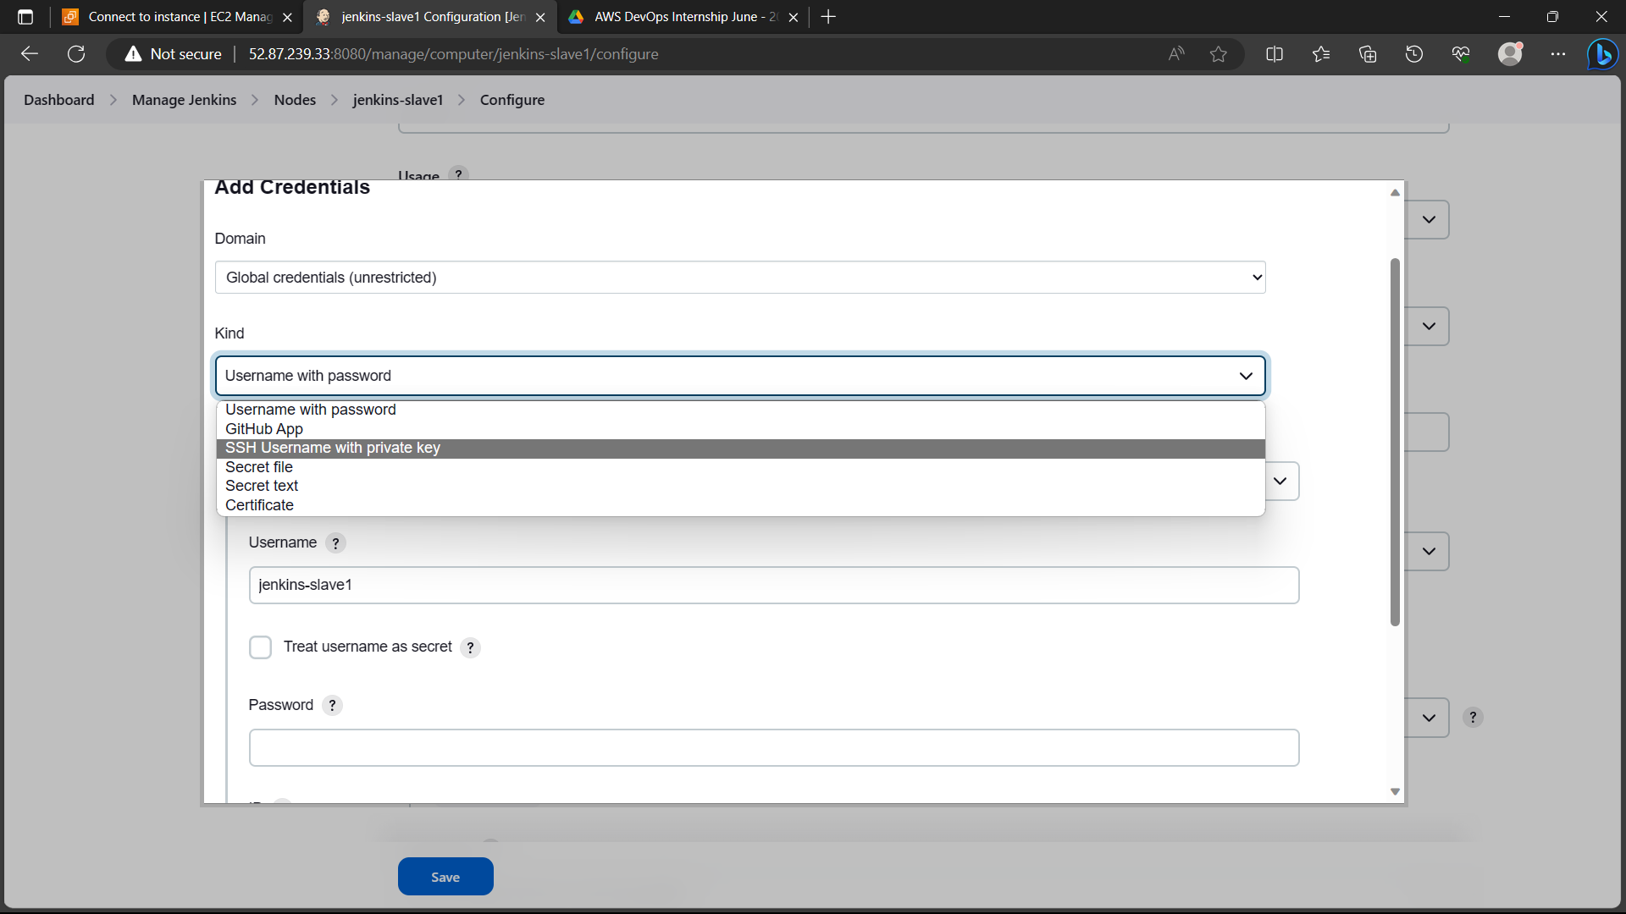

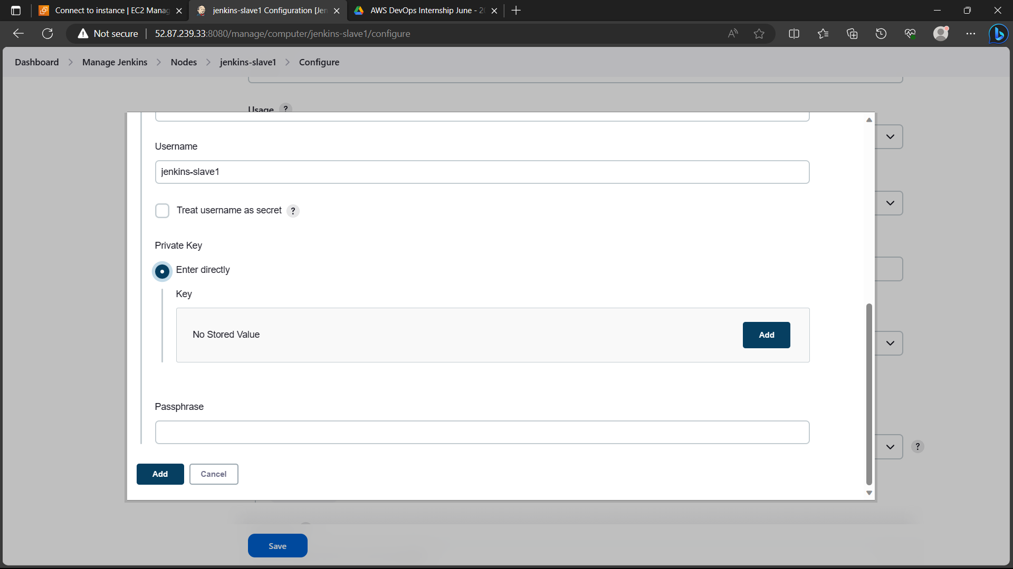

40)Go to slave instance and type the command “more id_rsa” copy the SSH key

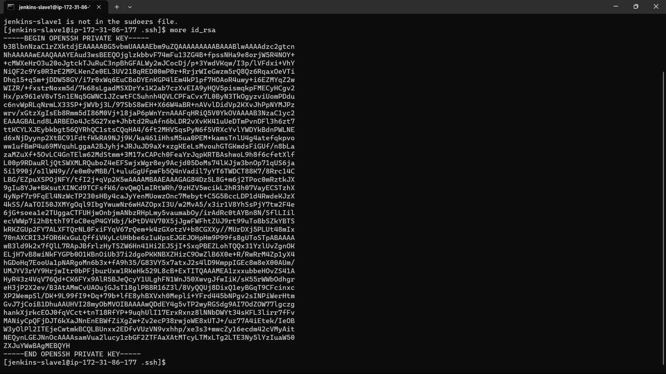

41)Paste in the key and click on “add”

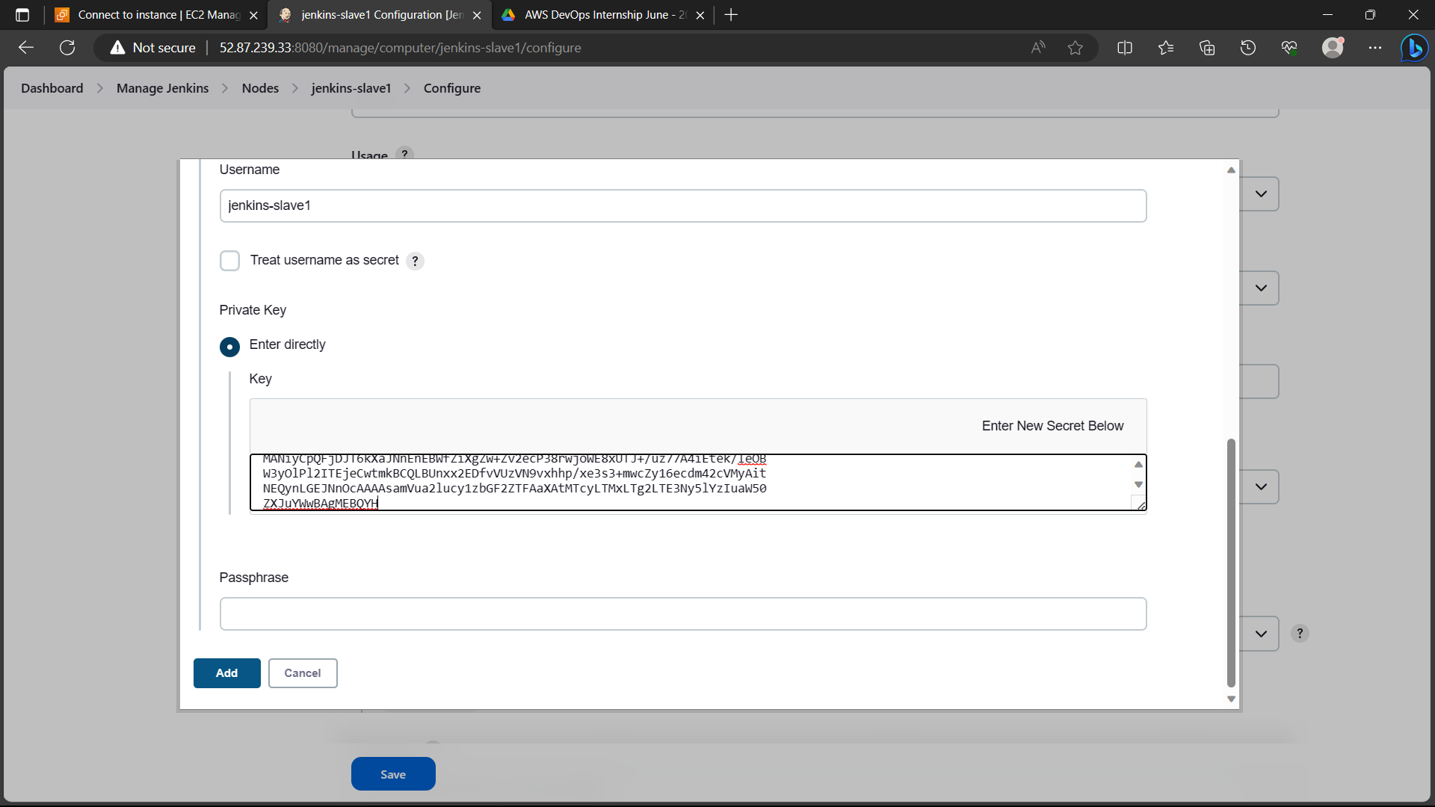

42)In host give the private IP address of slave instance and click “save”

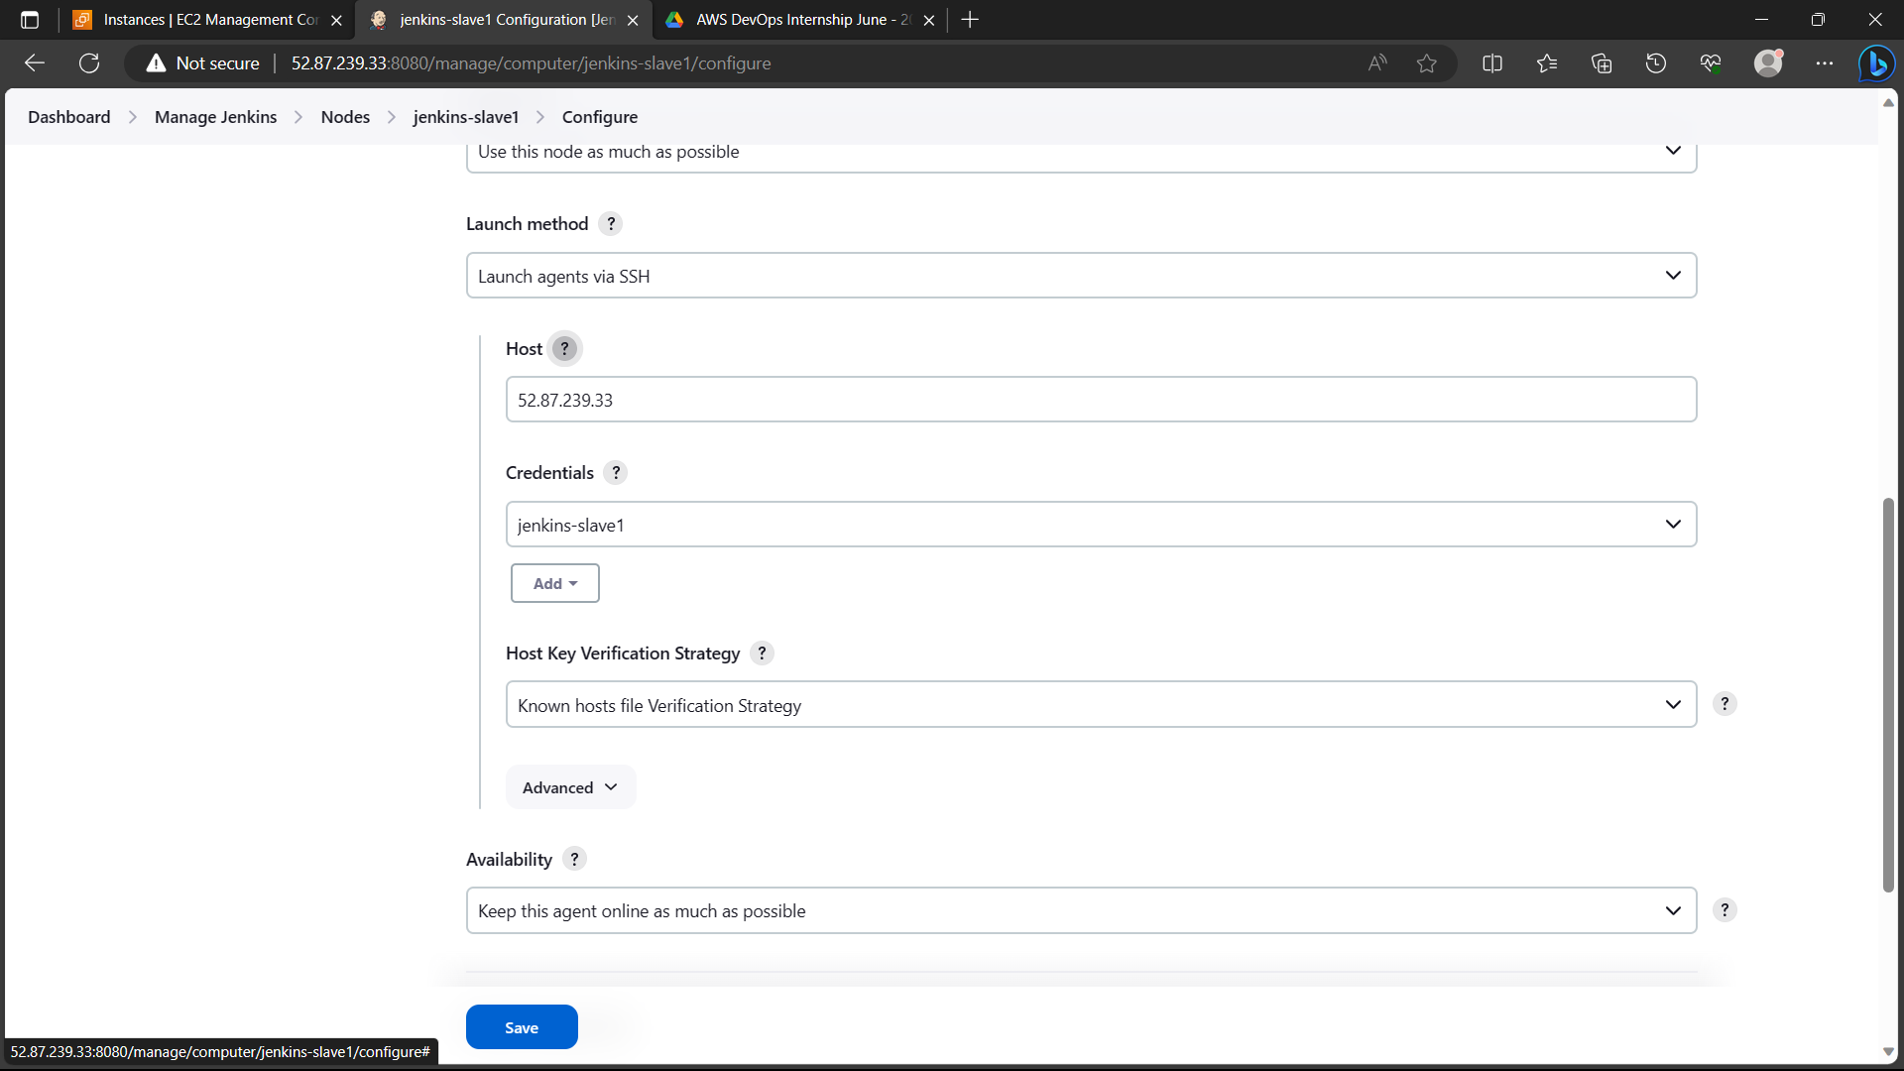

43)Click on “log”.

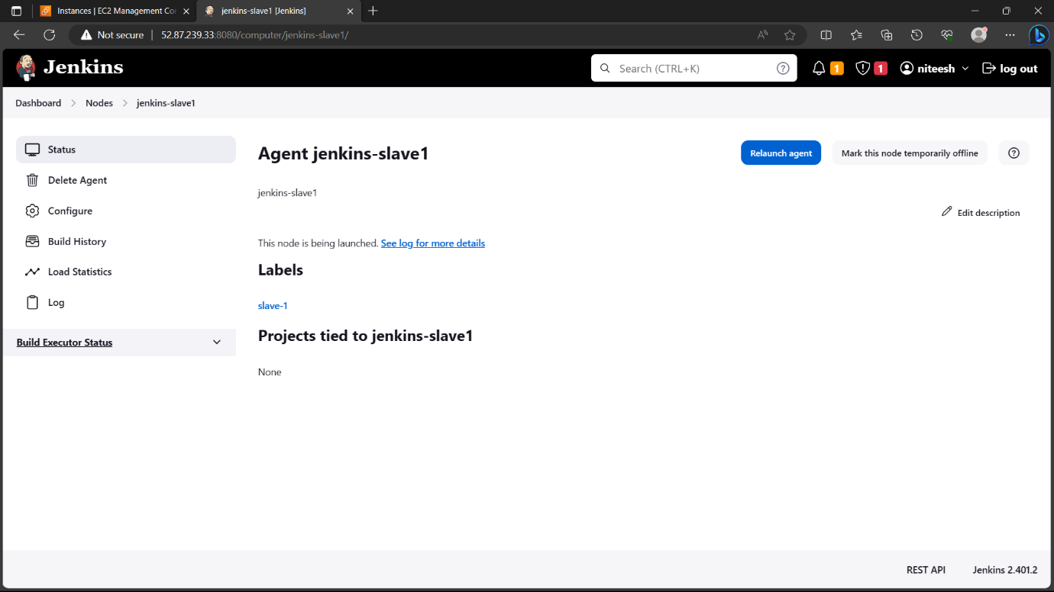

44)You can see the agent is online.

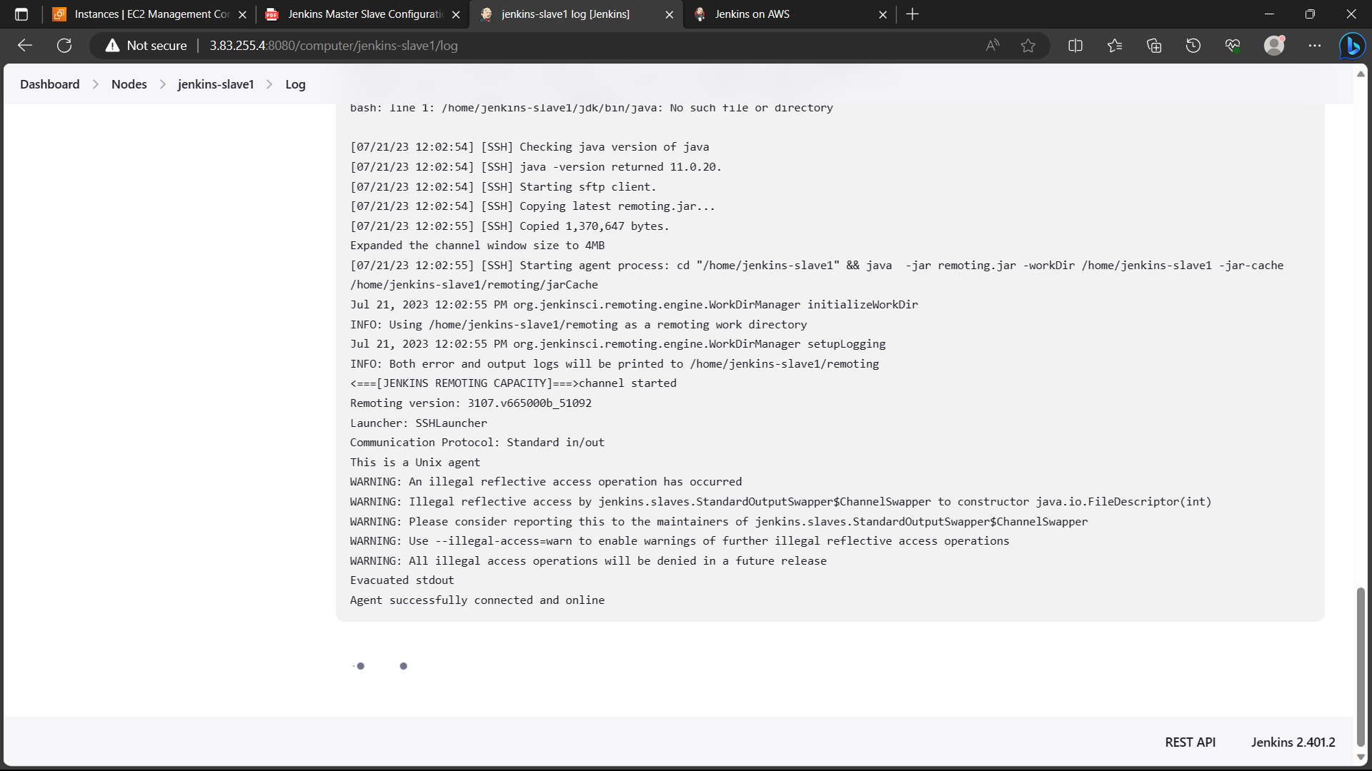

45)Click on “create a job”, give a name, freestyle project and click on ok

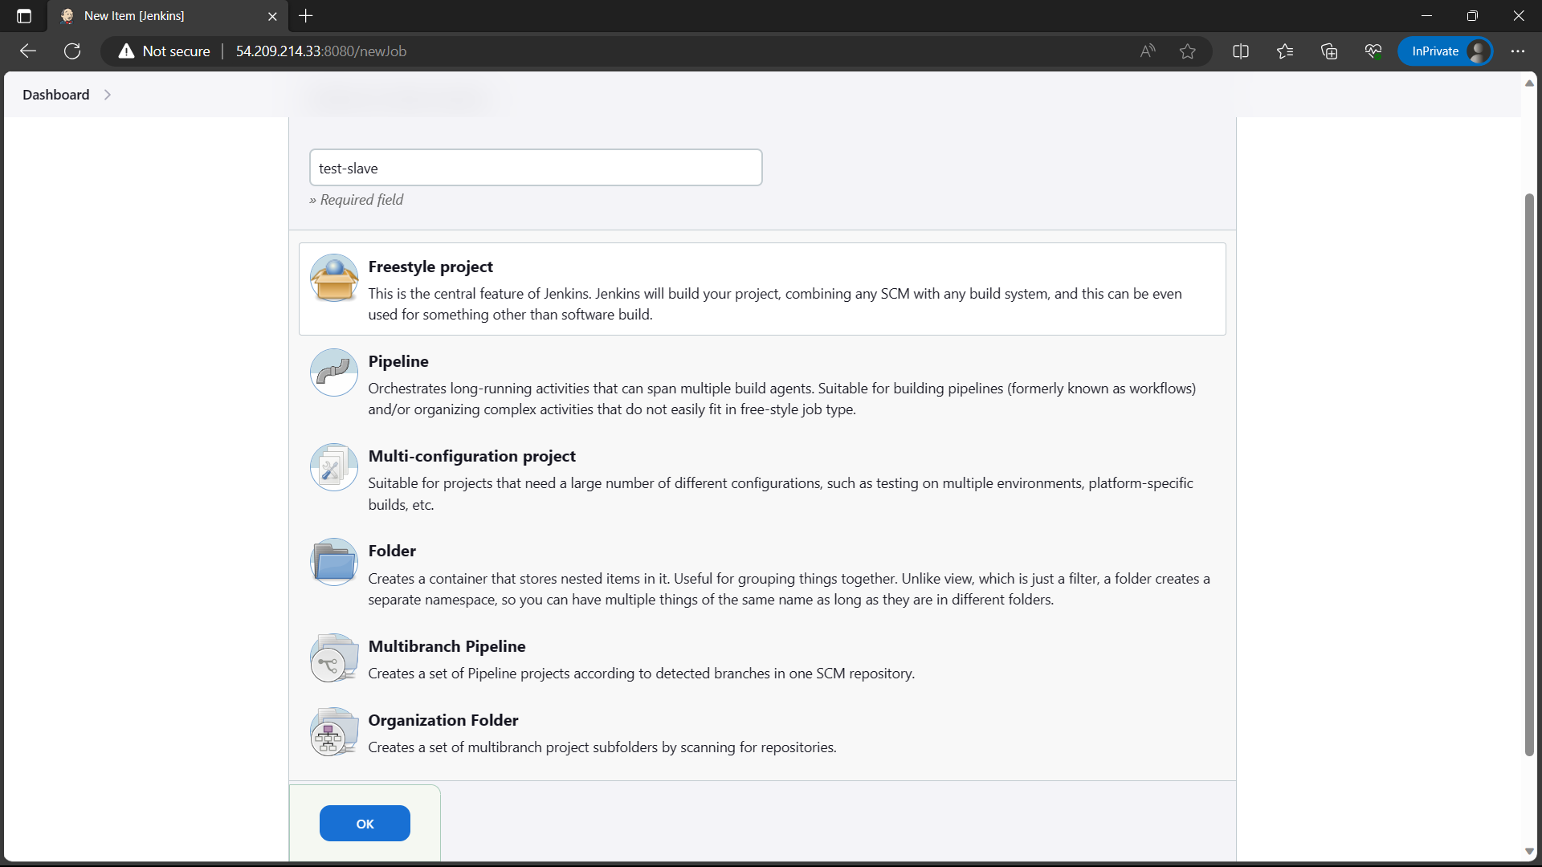

46)Select the “Restrict where project can run” and give the name of your node “Jenkins-slave1”.

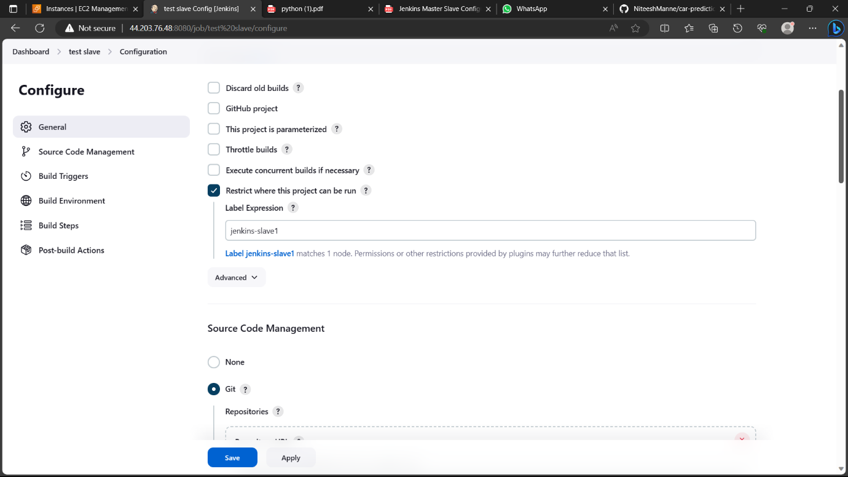

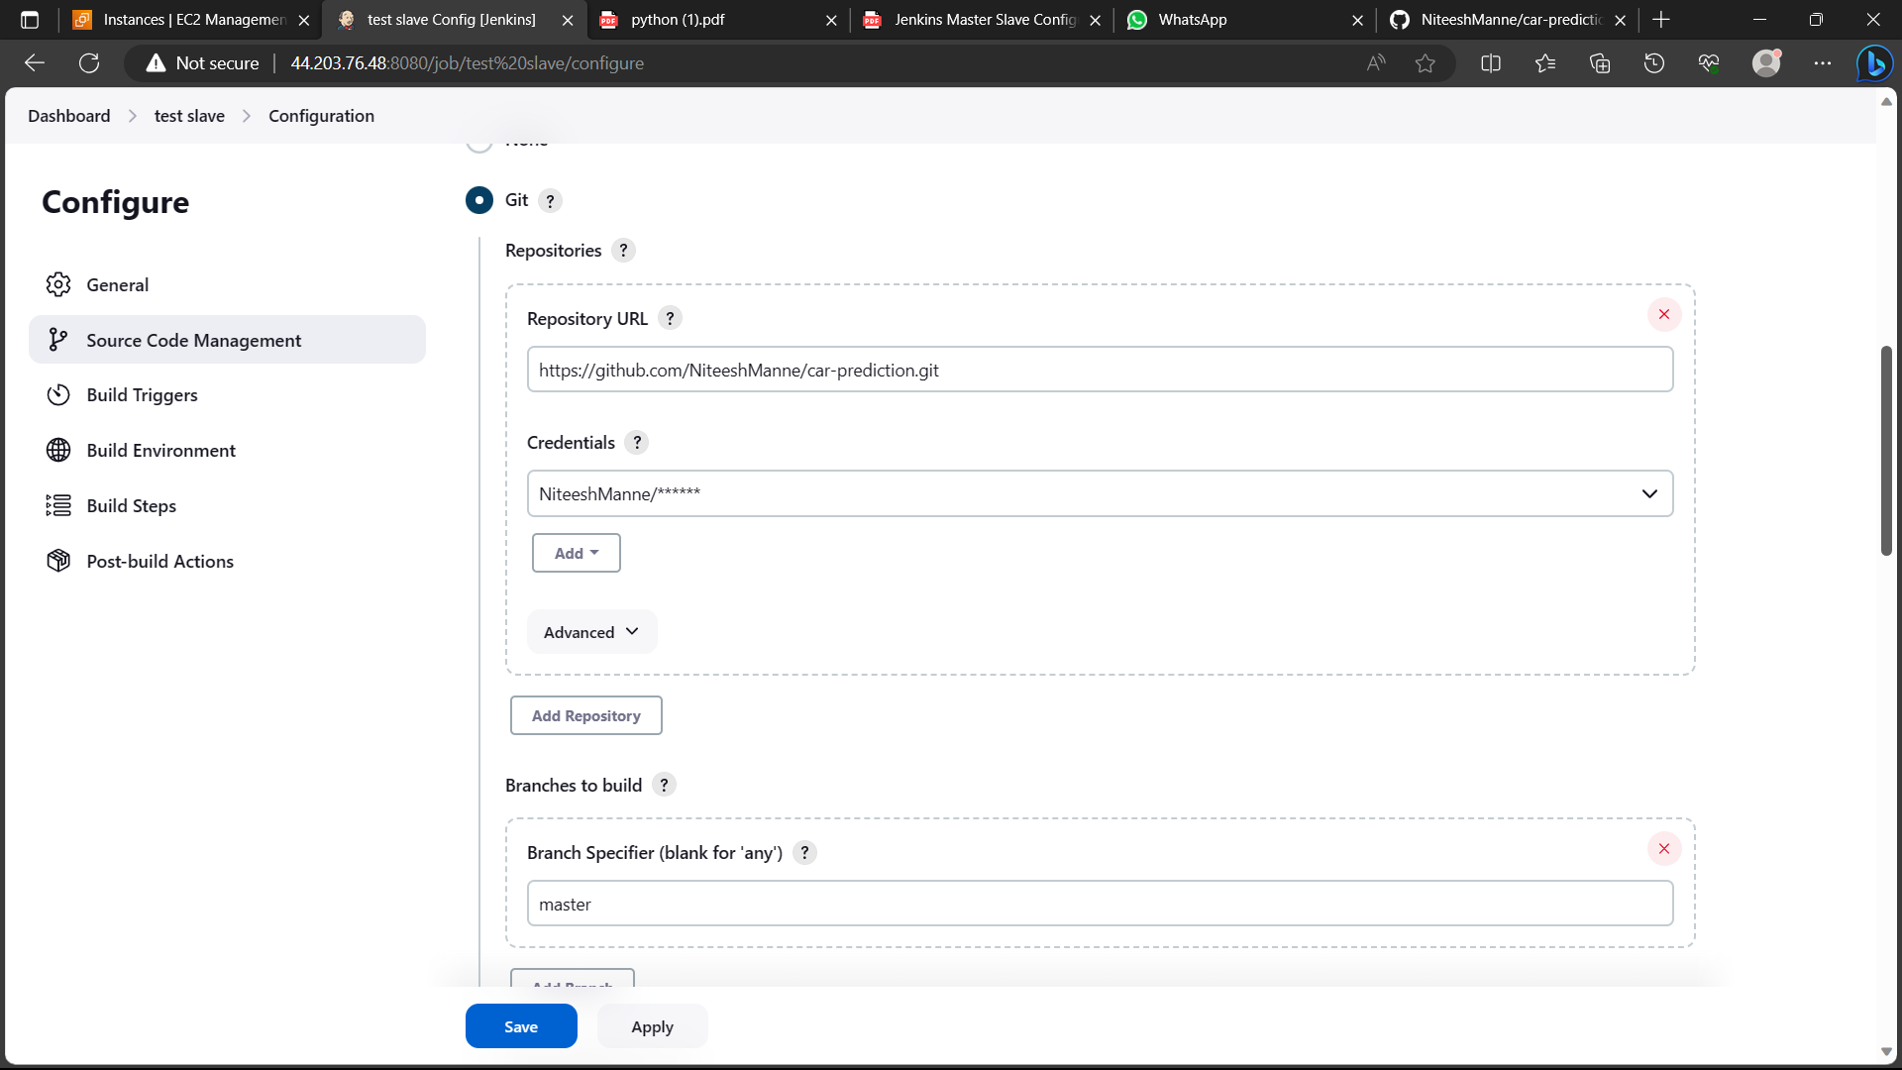

47)Click on build steps 🡪 execute shell command type the commands and click on save.

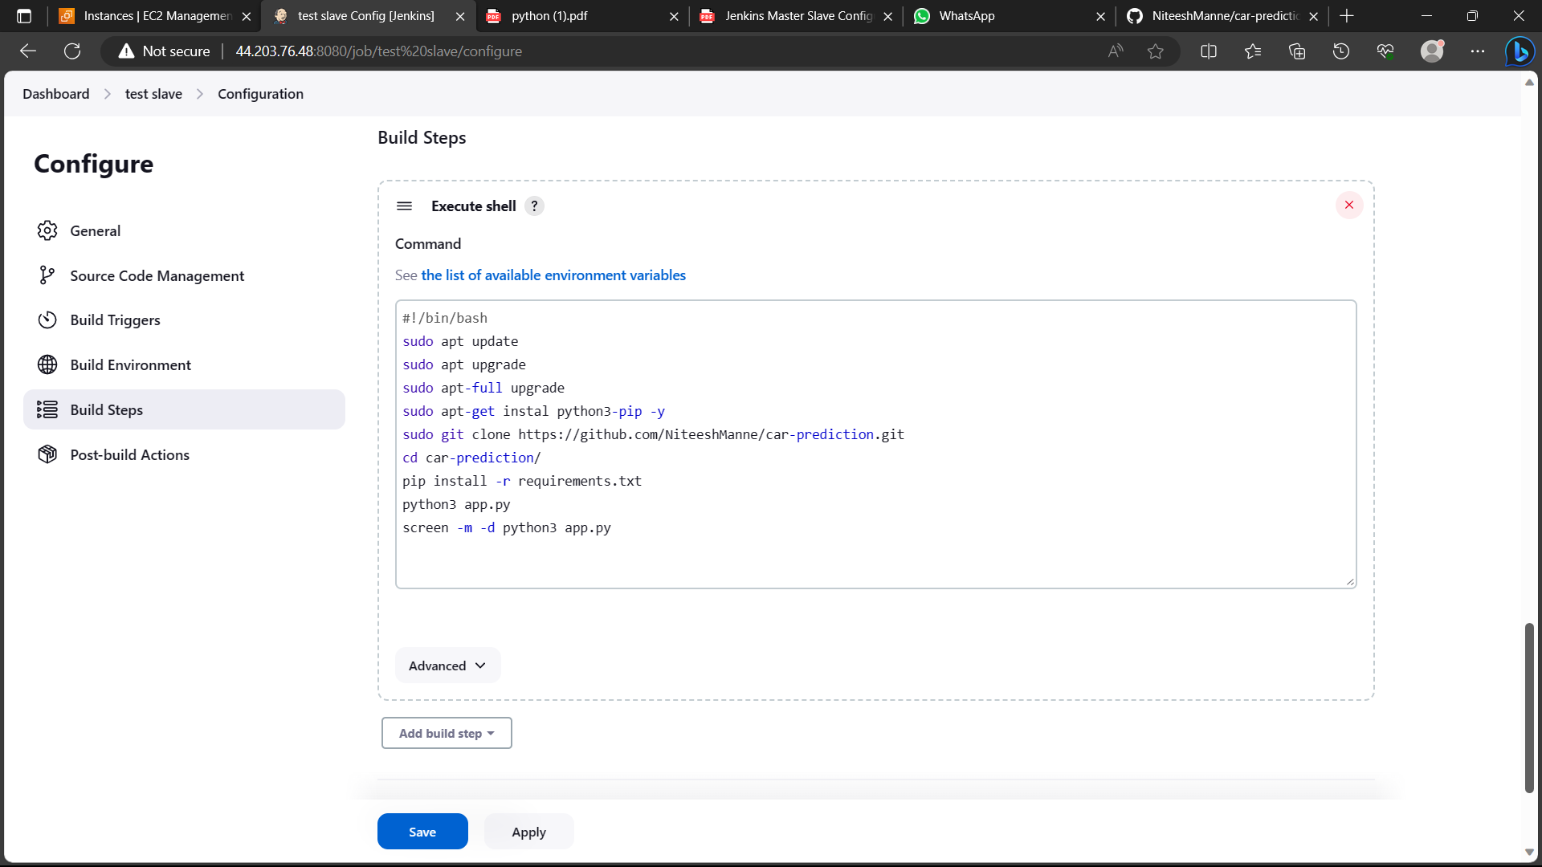

48)Click on build now and go to console output of that build

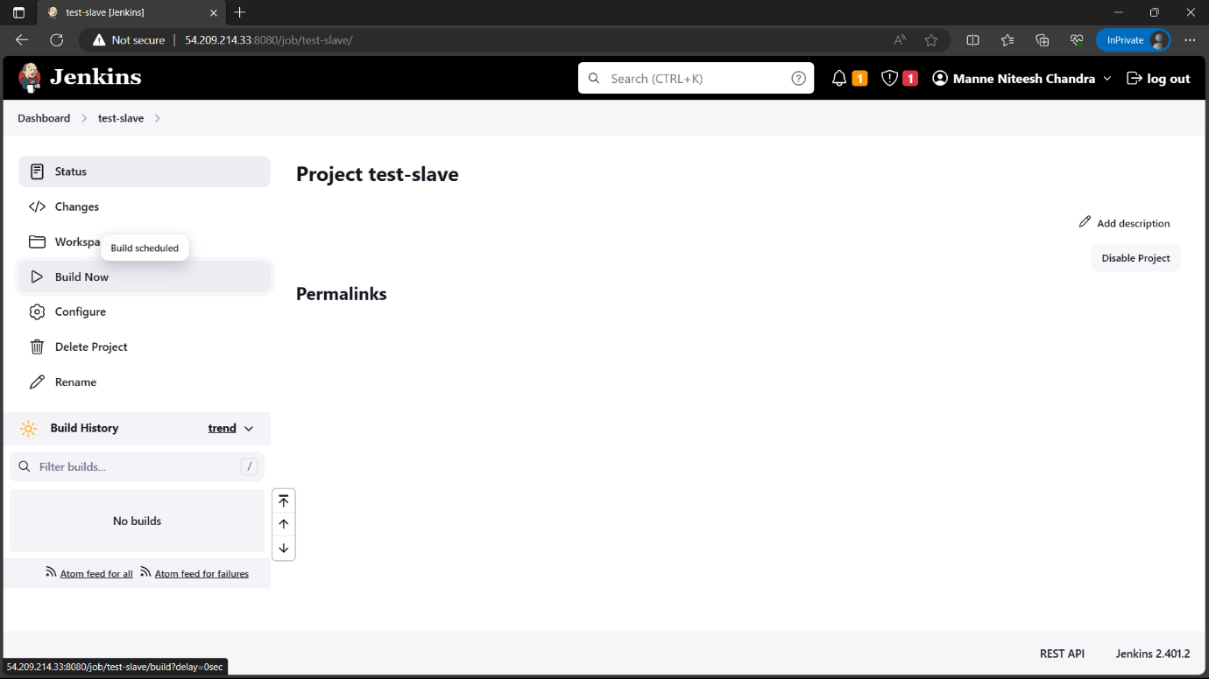

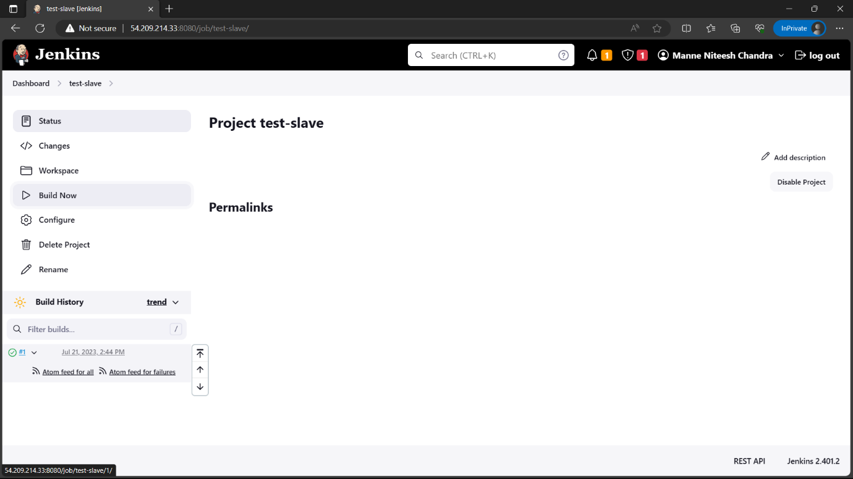

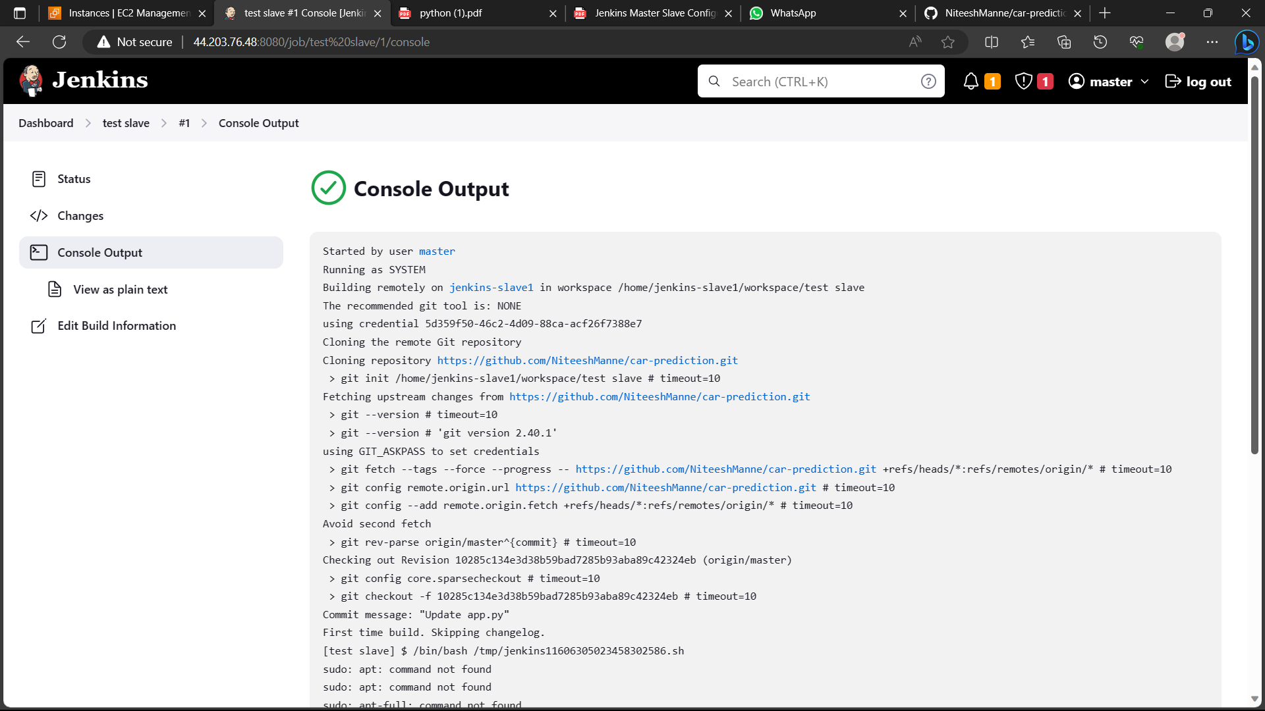

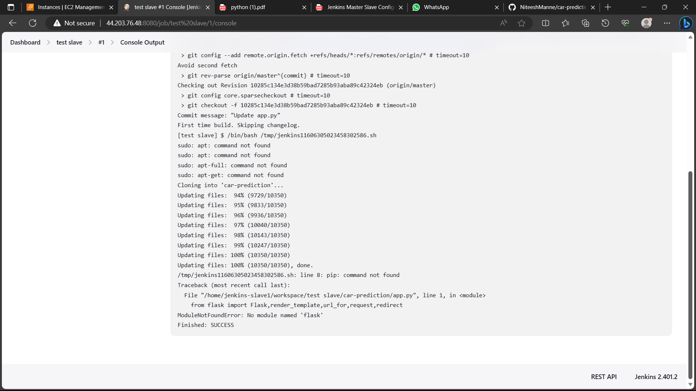

Part-3:

49)Create a slave and share the details of the slave to the master so that can connect to the slave and deploy the projects in the slave

Note: you can see the deployed projects in workspace of slave i.e., using the command “cd workspace”.

